**Java 8 Features:**

**Default Methods in Interface:**

Default methods enable you to **add new functionality to existing interfaces and ensure binary compatibility with code written for older versions of those interfaces**. In particular, default methods enable you to add methods that accept lambda expressions as parameters to existing interfaces.

These defaults methods cab be override by implementation classes.

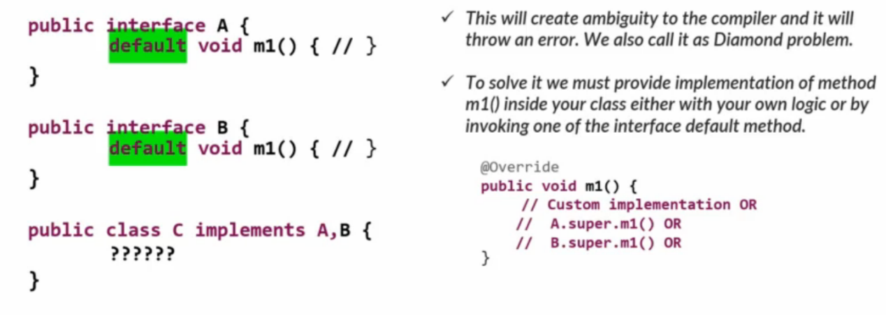

We can’t override the methods present inside the Object class as default methods inside a

interface. The compiler will throw errors if we do so.

We can’t write default methods inside a class. Even in the scenarios where we are overriding

the default keyword should not be used inside the class methods.

Realtime Example:

Suppose I have an interface vehical with default method as Auto Pilot mode.

Any of the vehical companies implementing this interface can use default behaviour as it is or they can implement/overirde thier own implementation.

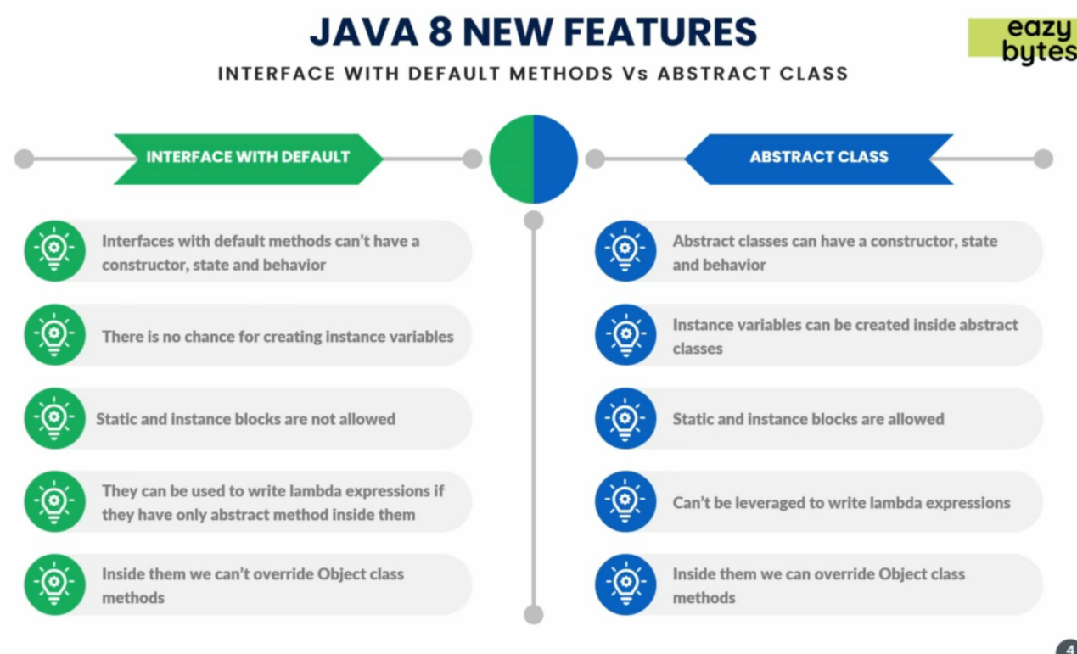

**Static Methods in Interfaces:**

From Java 8, just like we can write default methods inside interfaces, we can also write static

methods inside them to define any utility functionality.

• Since static methods don't belong to a particular object, they are not available to the classes implementing the interface, and they have to be called by using the interface name preceding the method name.

• Defining a static method within an interface is similar to defining one in a class.

• Static methods in interfaces make possible to group related utility methods, without having

to create artificial utility classes that are simply placeholders for static methods.

• Since interface static methods by default not available to the implementation class,

overriding concept is not applicable.

• Based on our requirement we can define exactly same method in the implementation class,

it’s valid but not overriding.

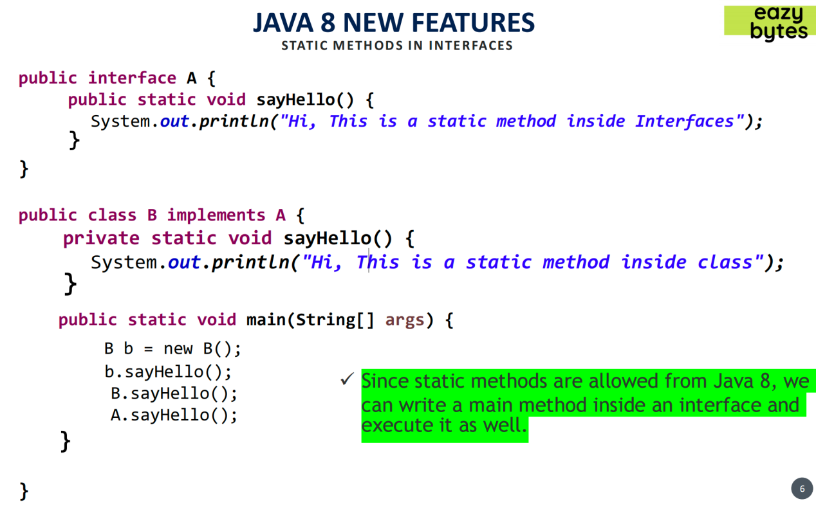

Can we execute Interface & print helloWorld()?

Yes. we can include main method in interface since java8 onwards we can include static methods. we can write main methos in interface & execute interface similar to java application.

**Optional to deal with Nulls:**

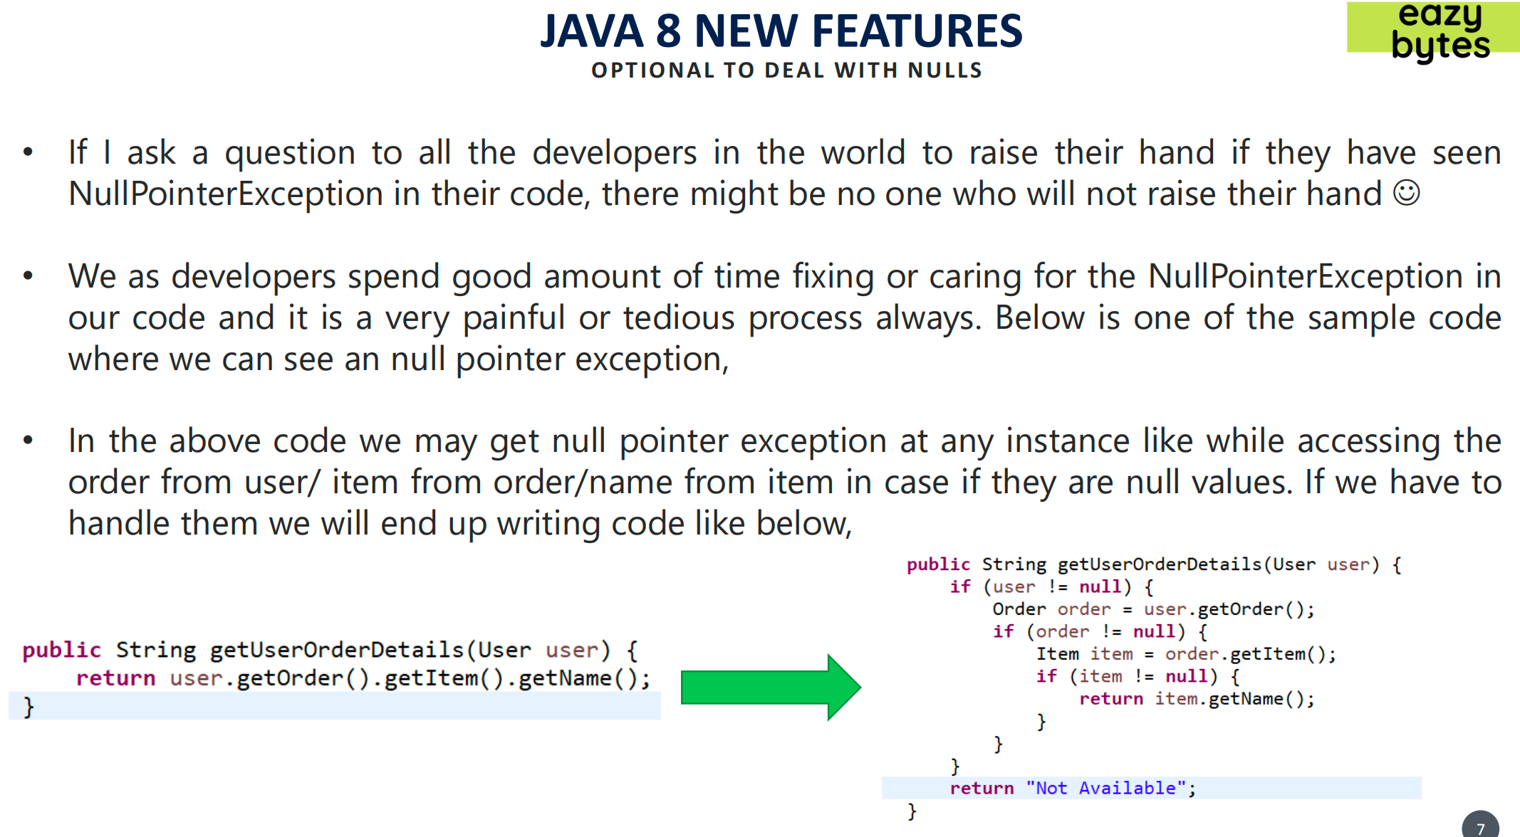

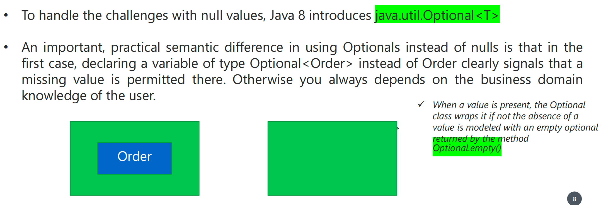

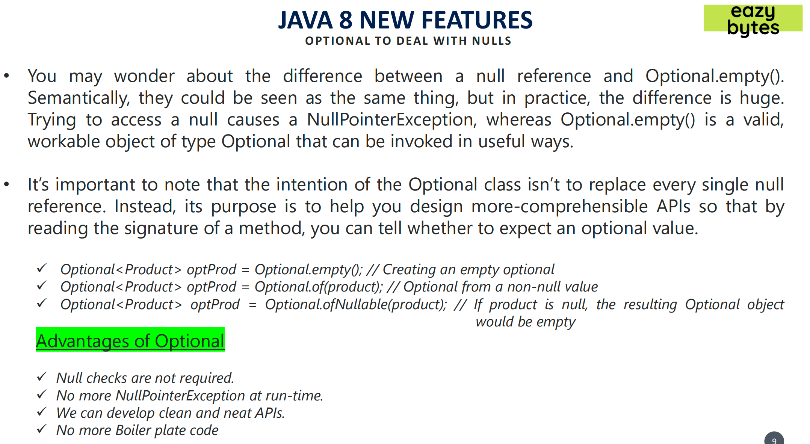

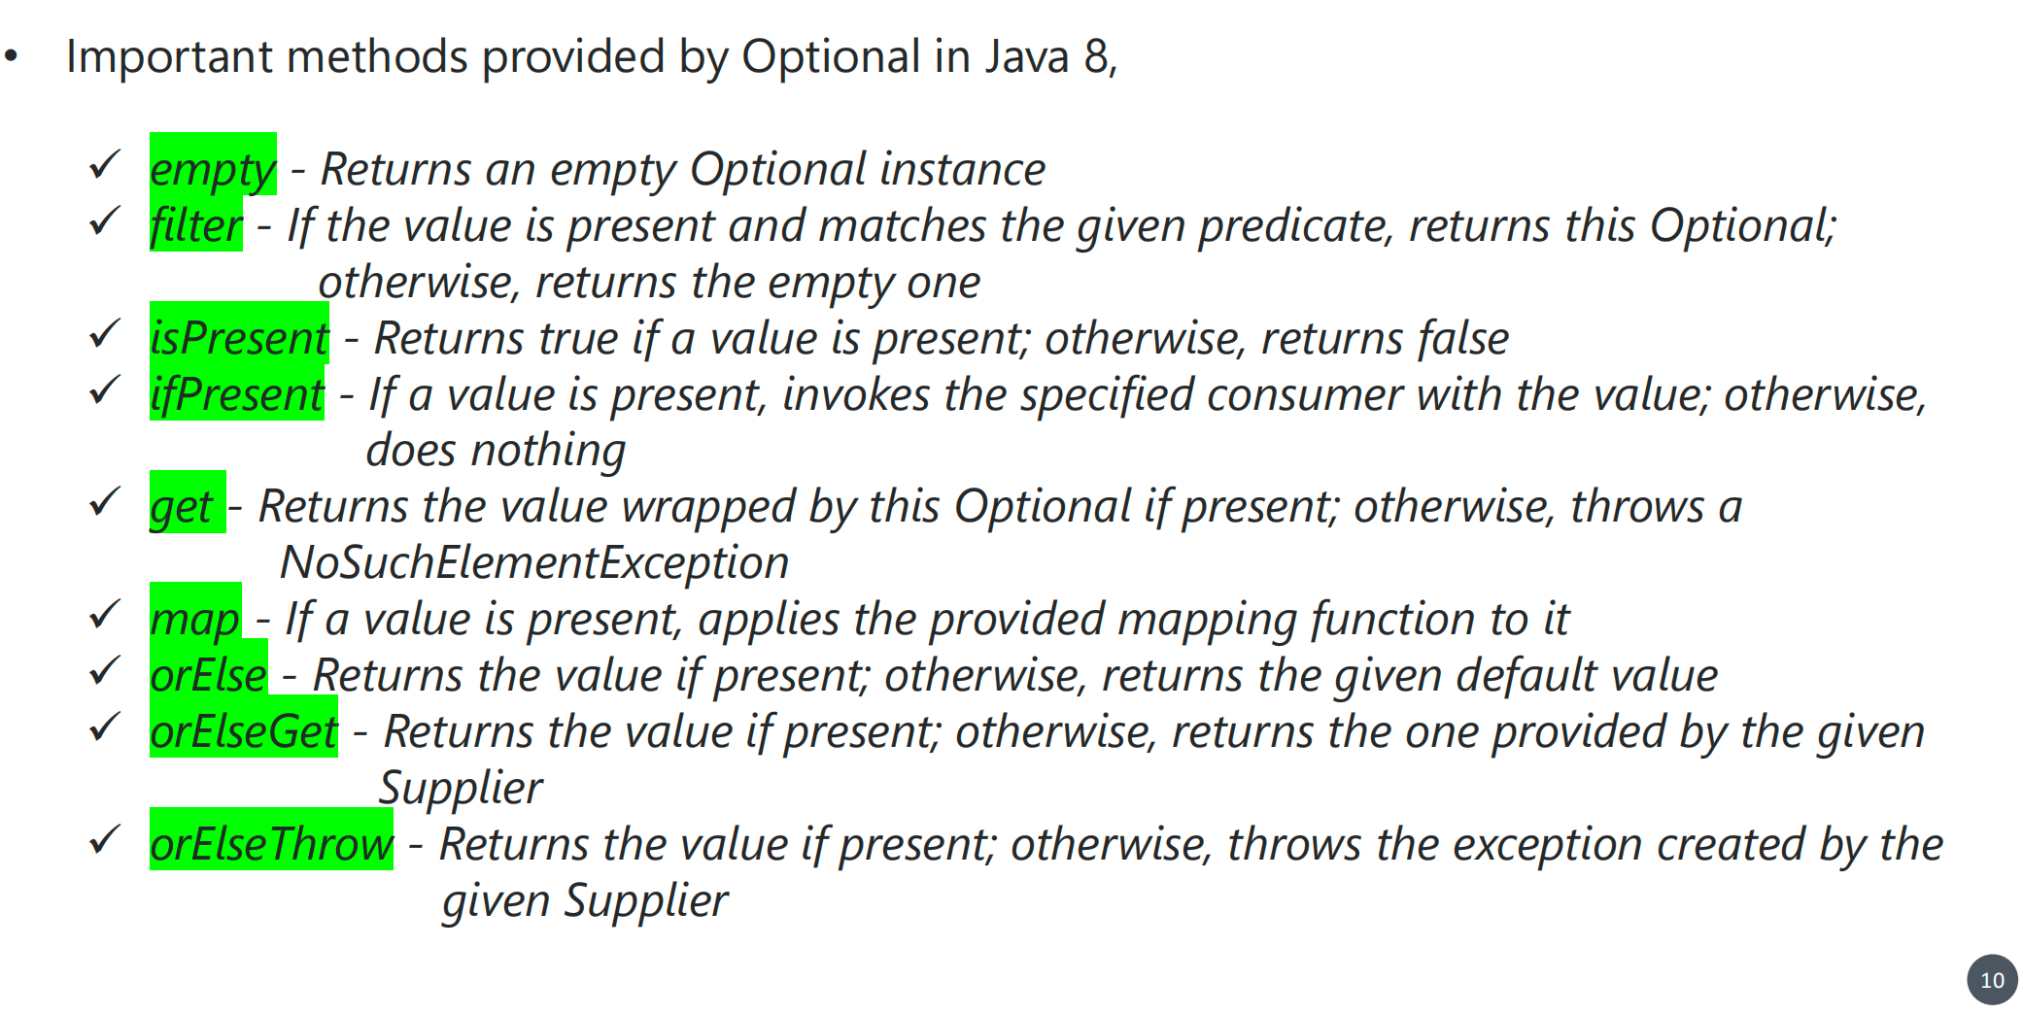

**LAMBDA Expression:**

A “lambda expression” is a block of code that you can pass around so it can be executed later, once or multiple times. It is an anonymous (nameless) function. That means the function which doesn’t have the name, return type and access modifiers.

• It enable to treat functionality as a method argument, or code as data.

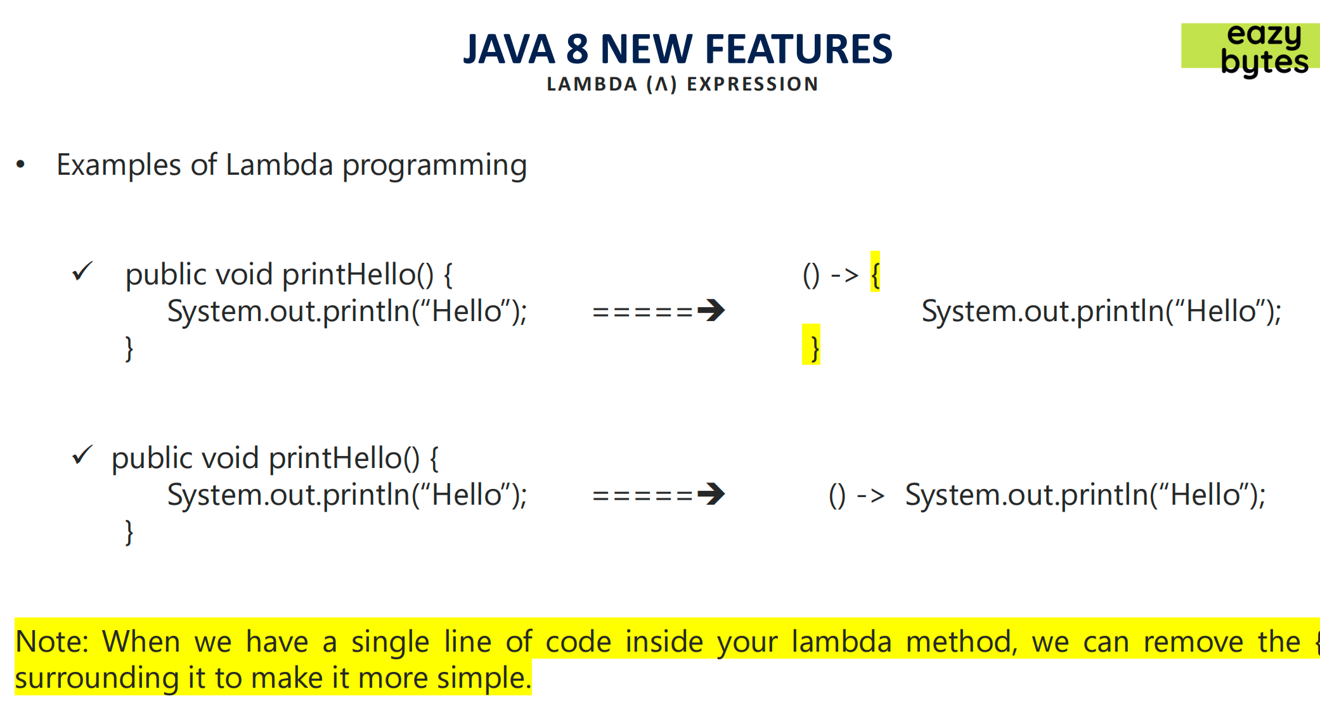

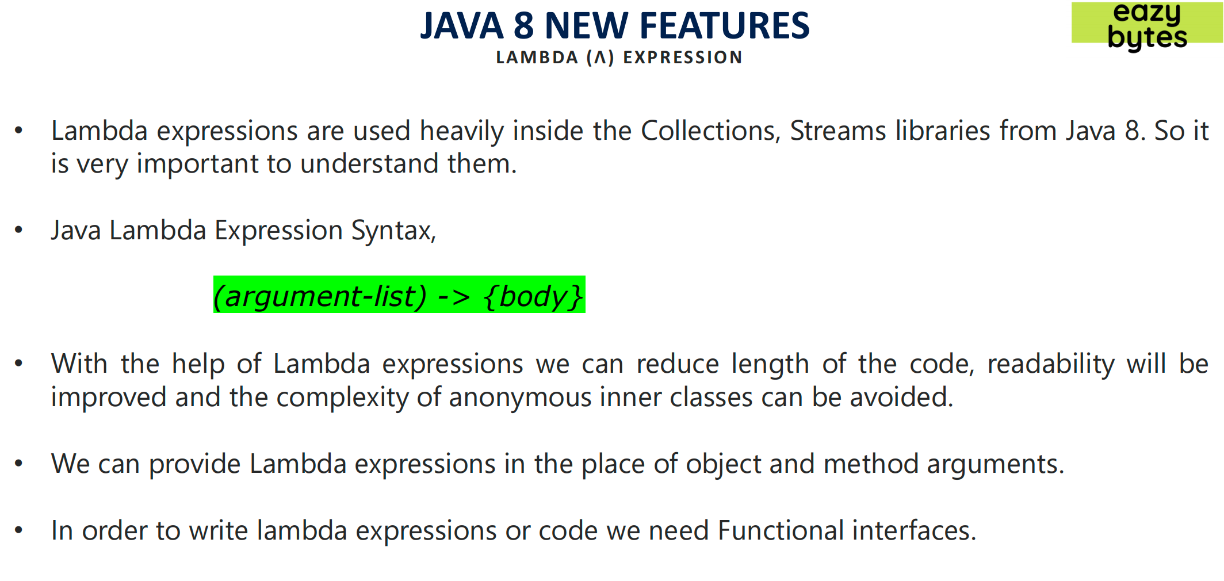

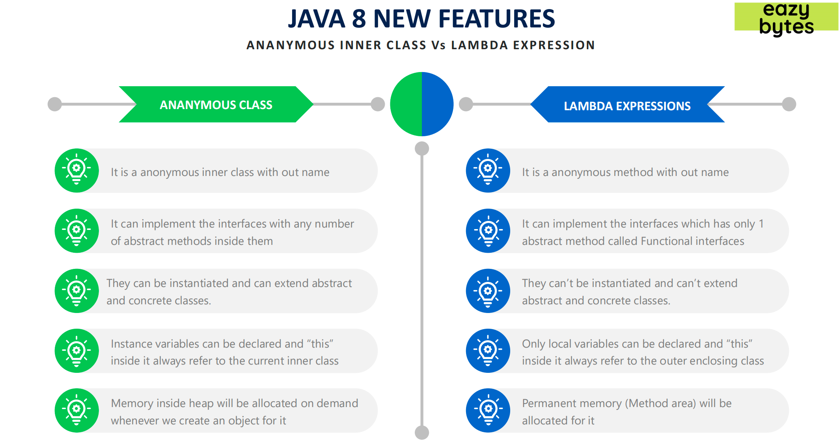

**Functional Interfaces:**

Functional interfaces contains only one abstract method. Below are the thumb rules for

Functional interfaces,

✓ Only 1 abstract method is allowed (Also called as SAM – Single Abstract method)

✓ Any number of default methods are allowed

✓ Any number of static methods are allowed

✓ Any number of private methods are allowed

• Since functional interfaces has only one abstract method, we can write lambda code/pass the implementation behavior of it using lambda code. Since there is only one unimplemented

method inside interface compiler doesn’t complain for method name, parameters datatype,

return type of the method etc.

• In Java 8, a new annotation @FunctionalInterface is introduced to mark an interface as

Functional interface. With this if in future if any one try to add another abstract method,

compiler will throw an error.

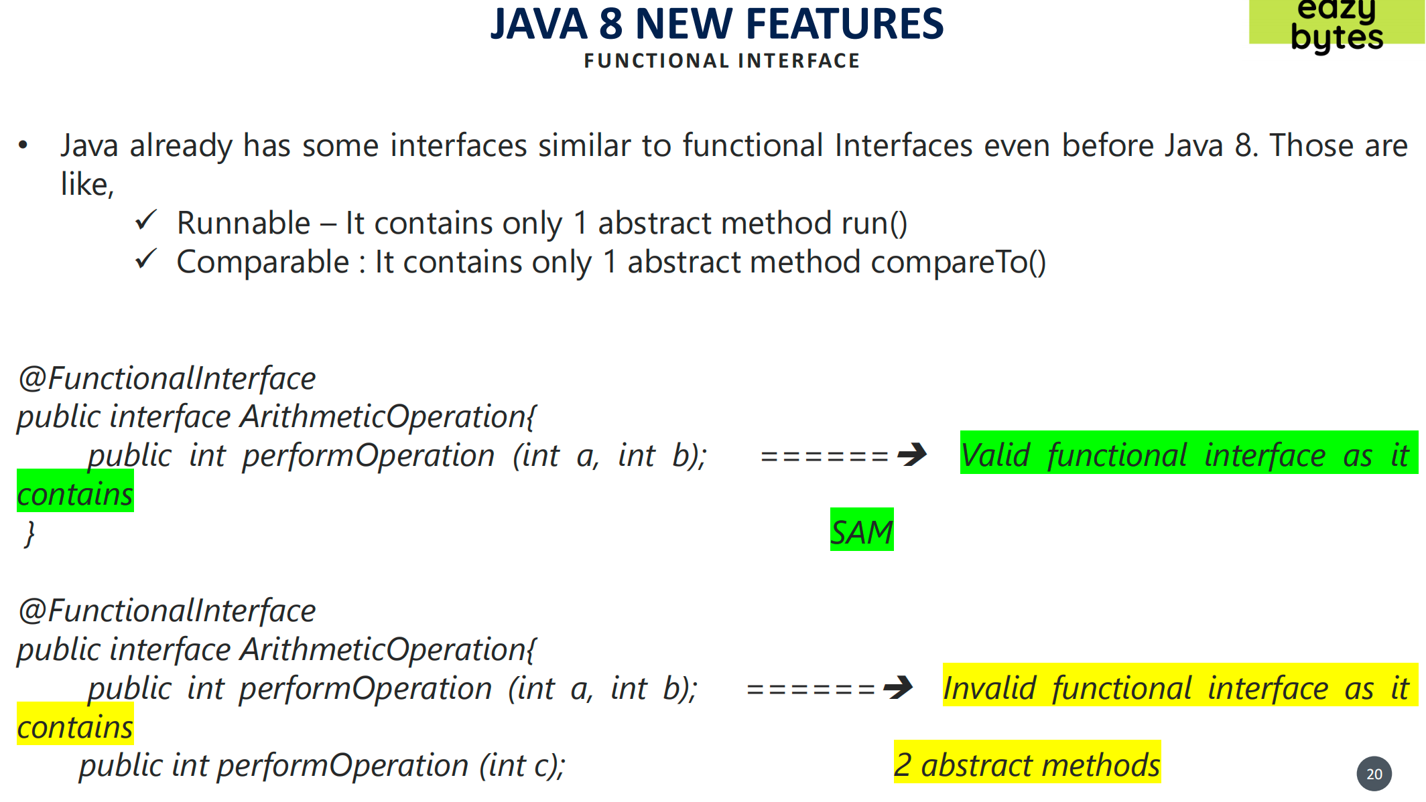

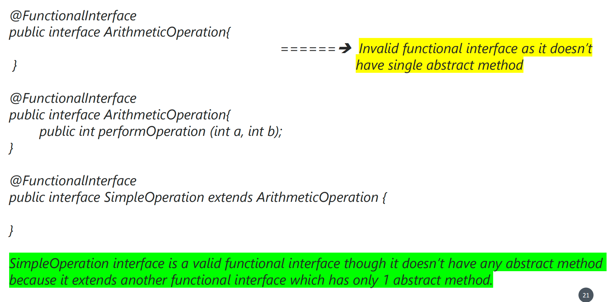

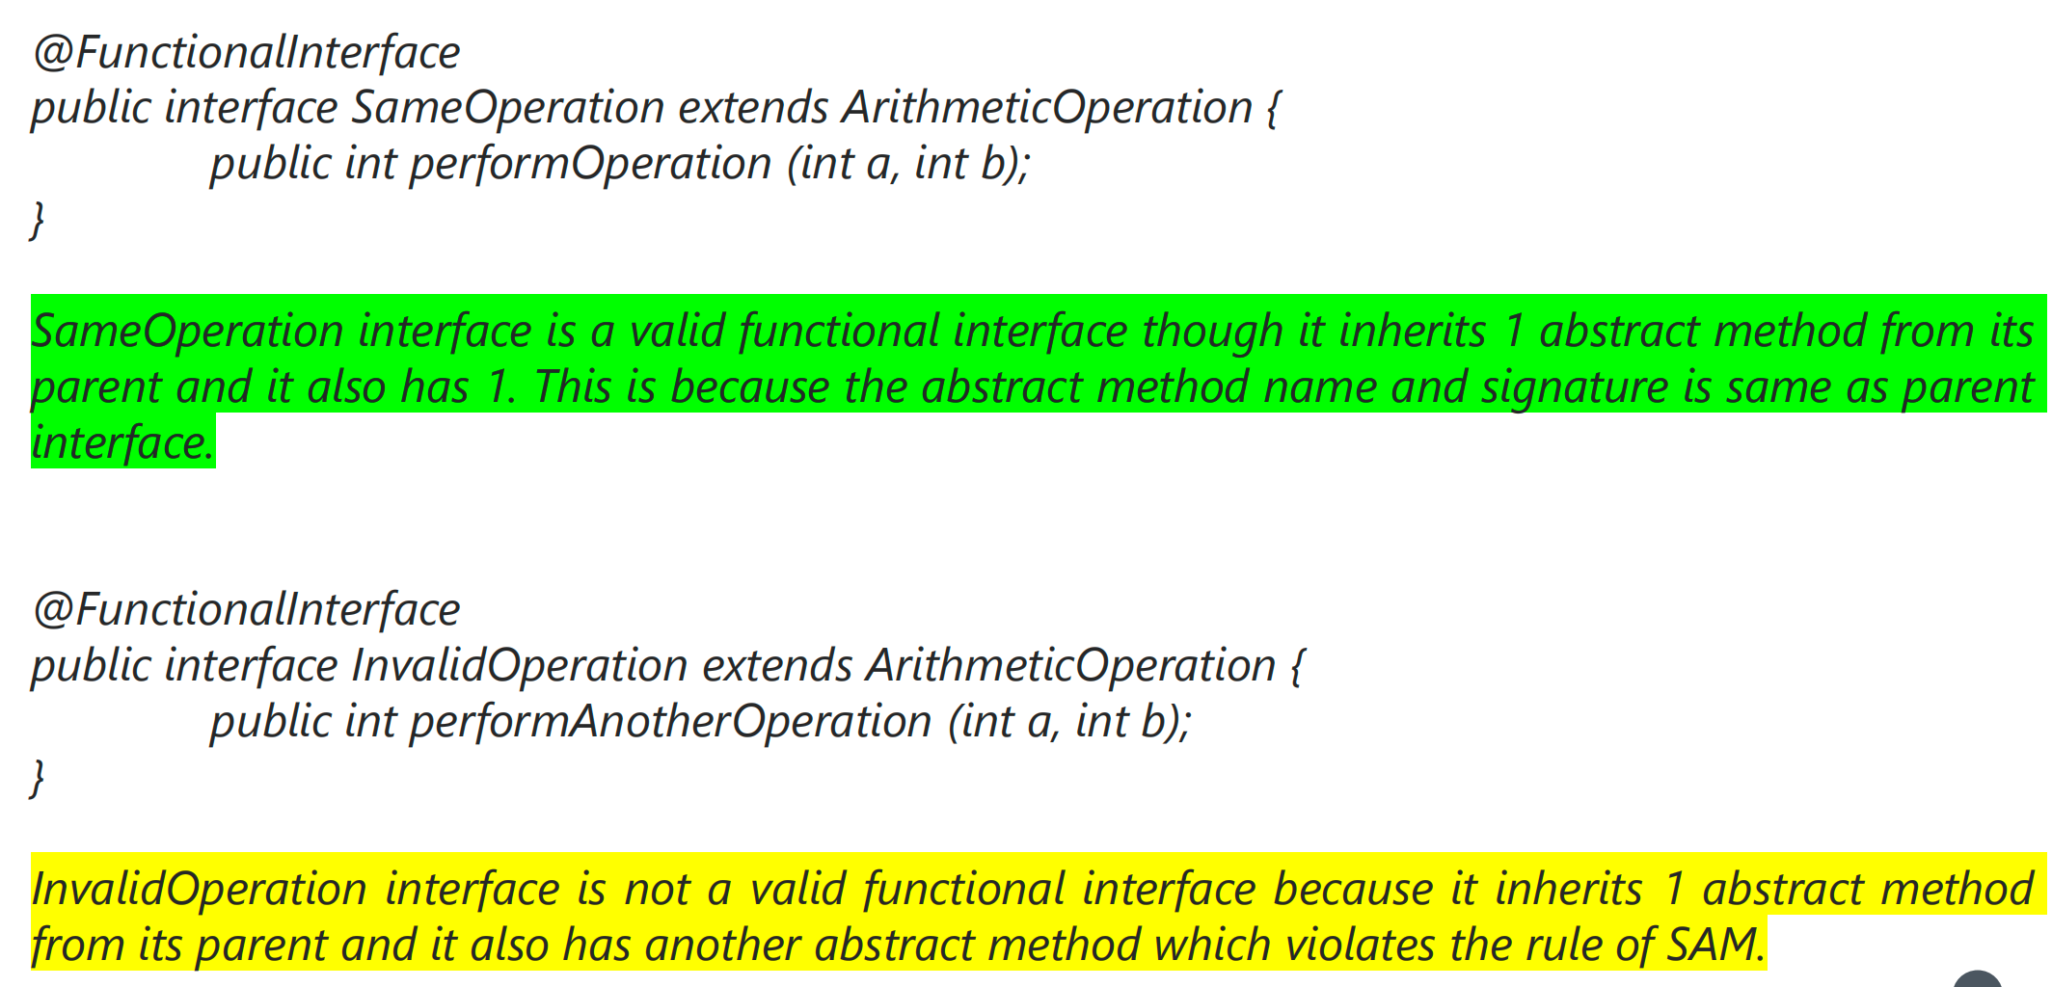

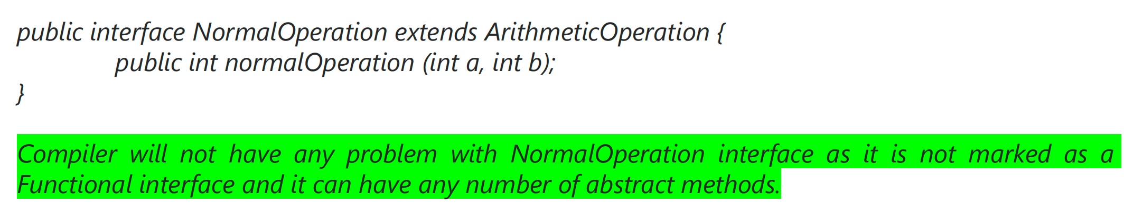

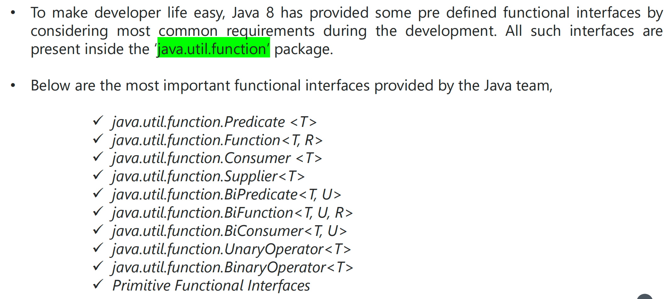

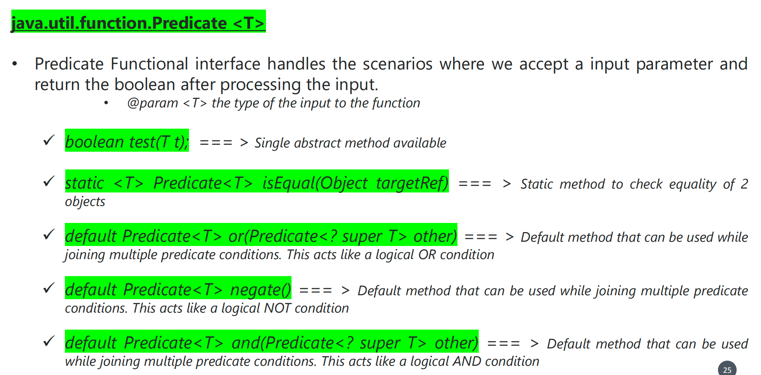

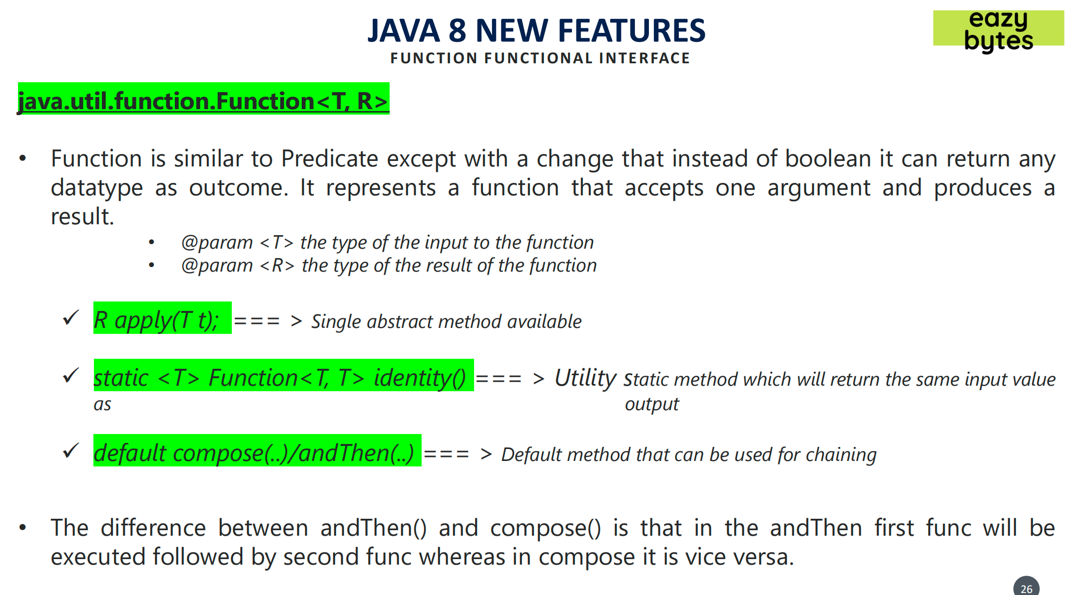

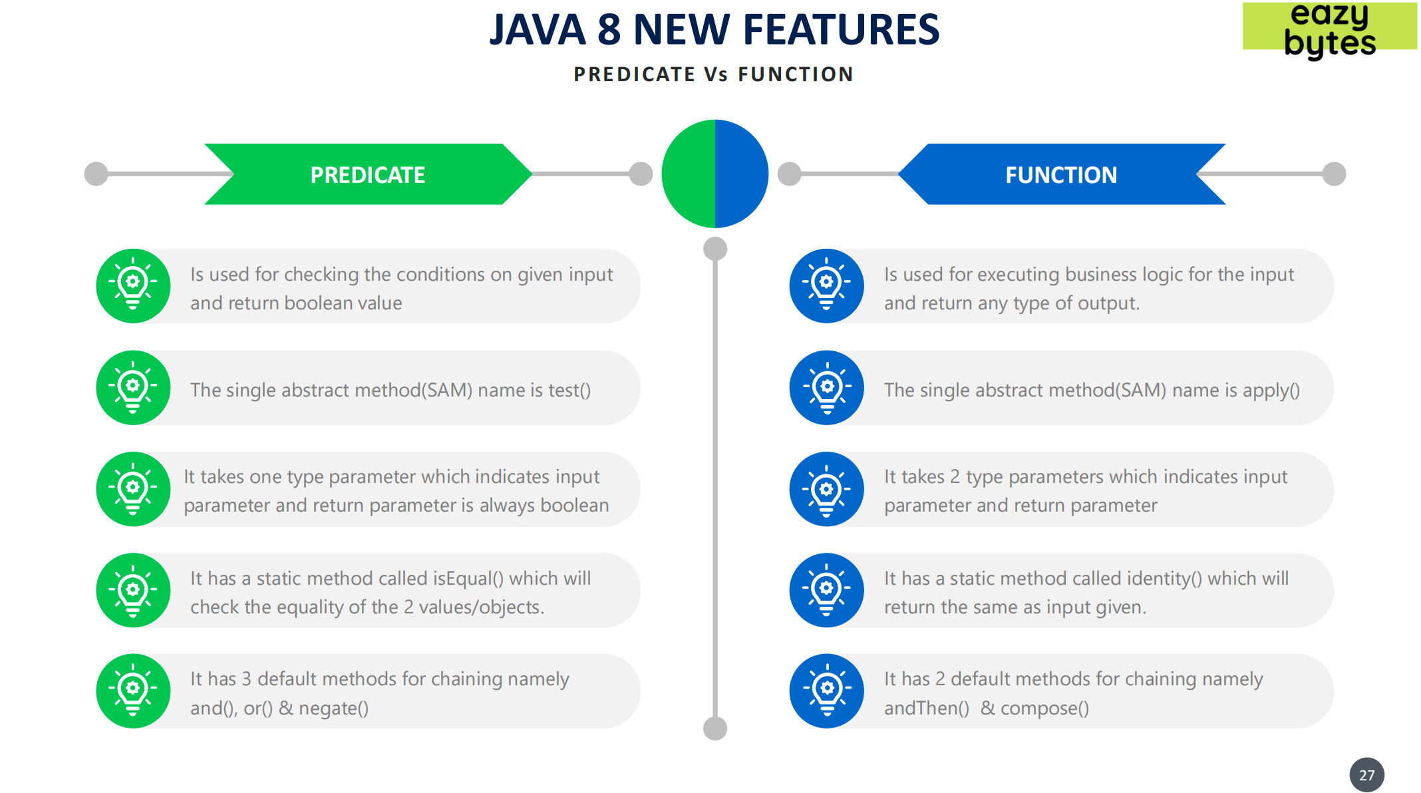

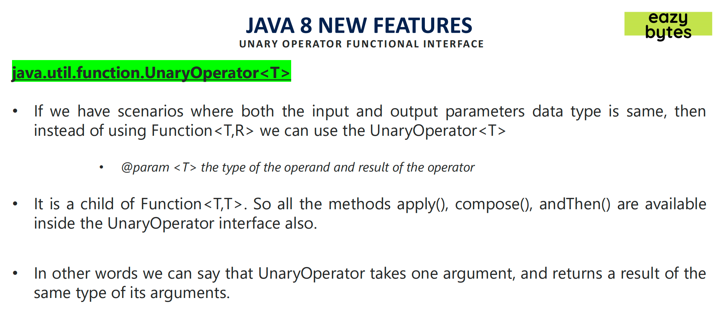

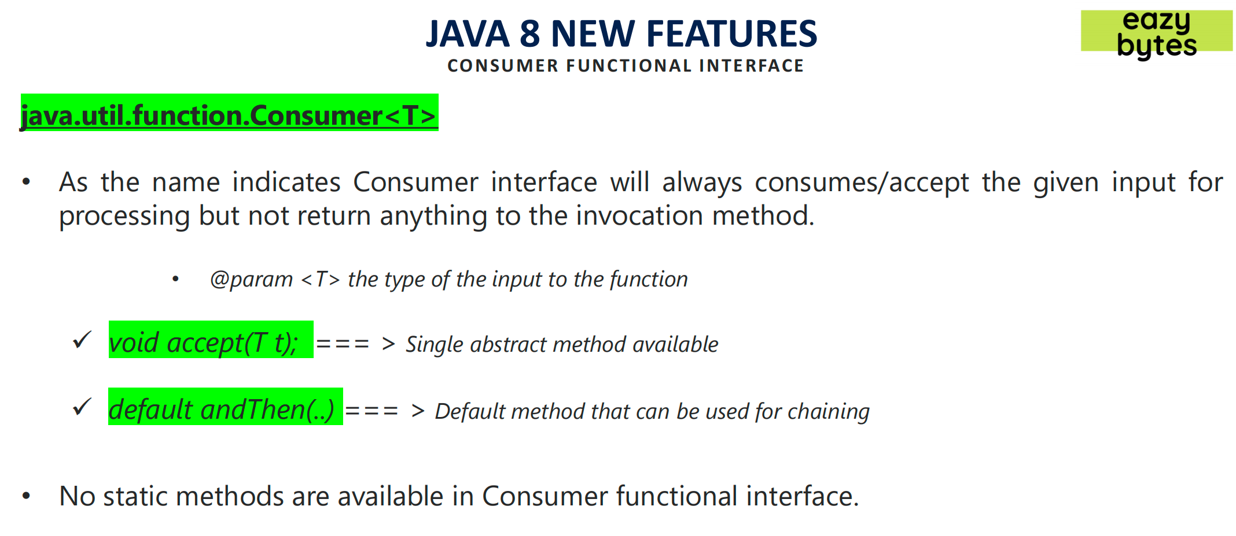

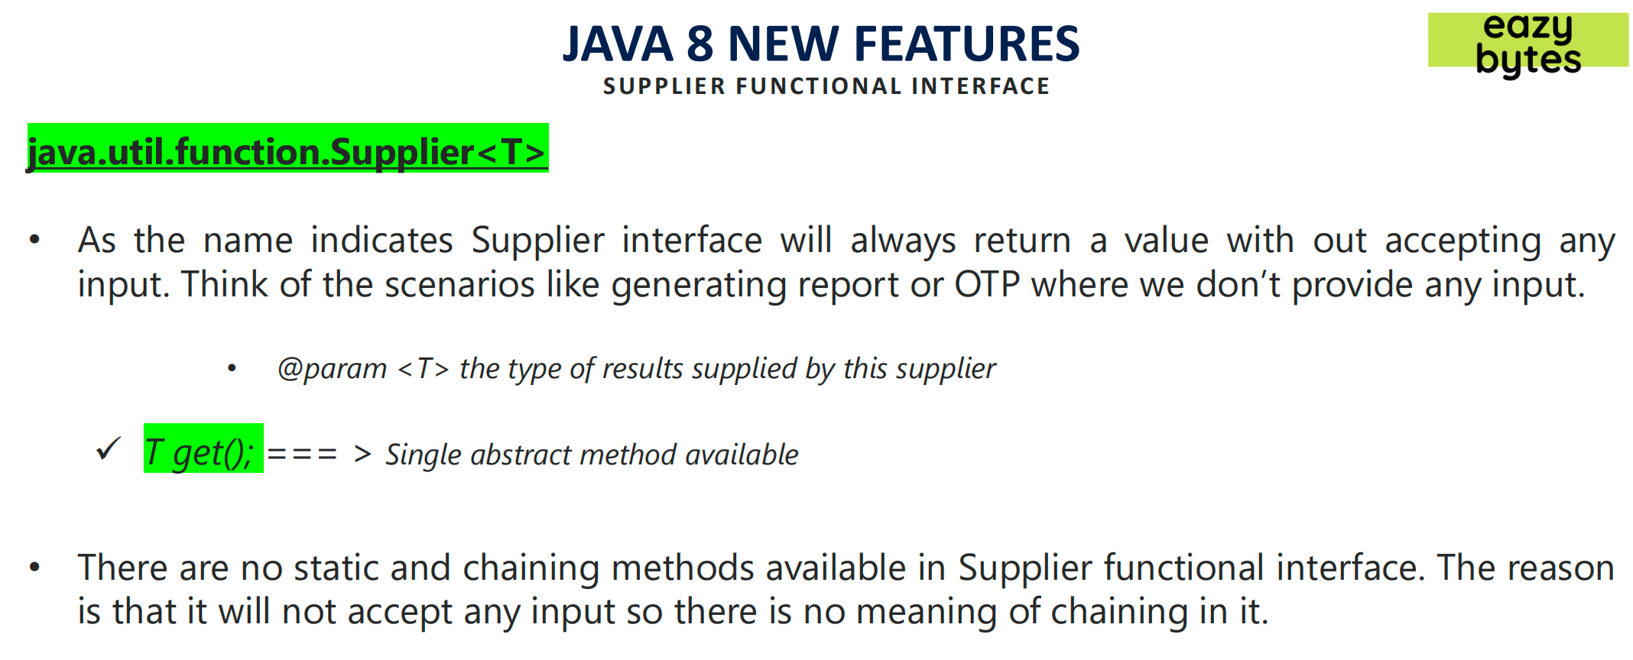

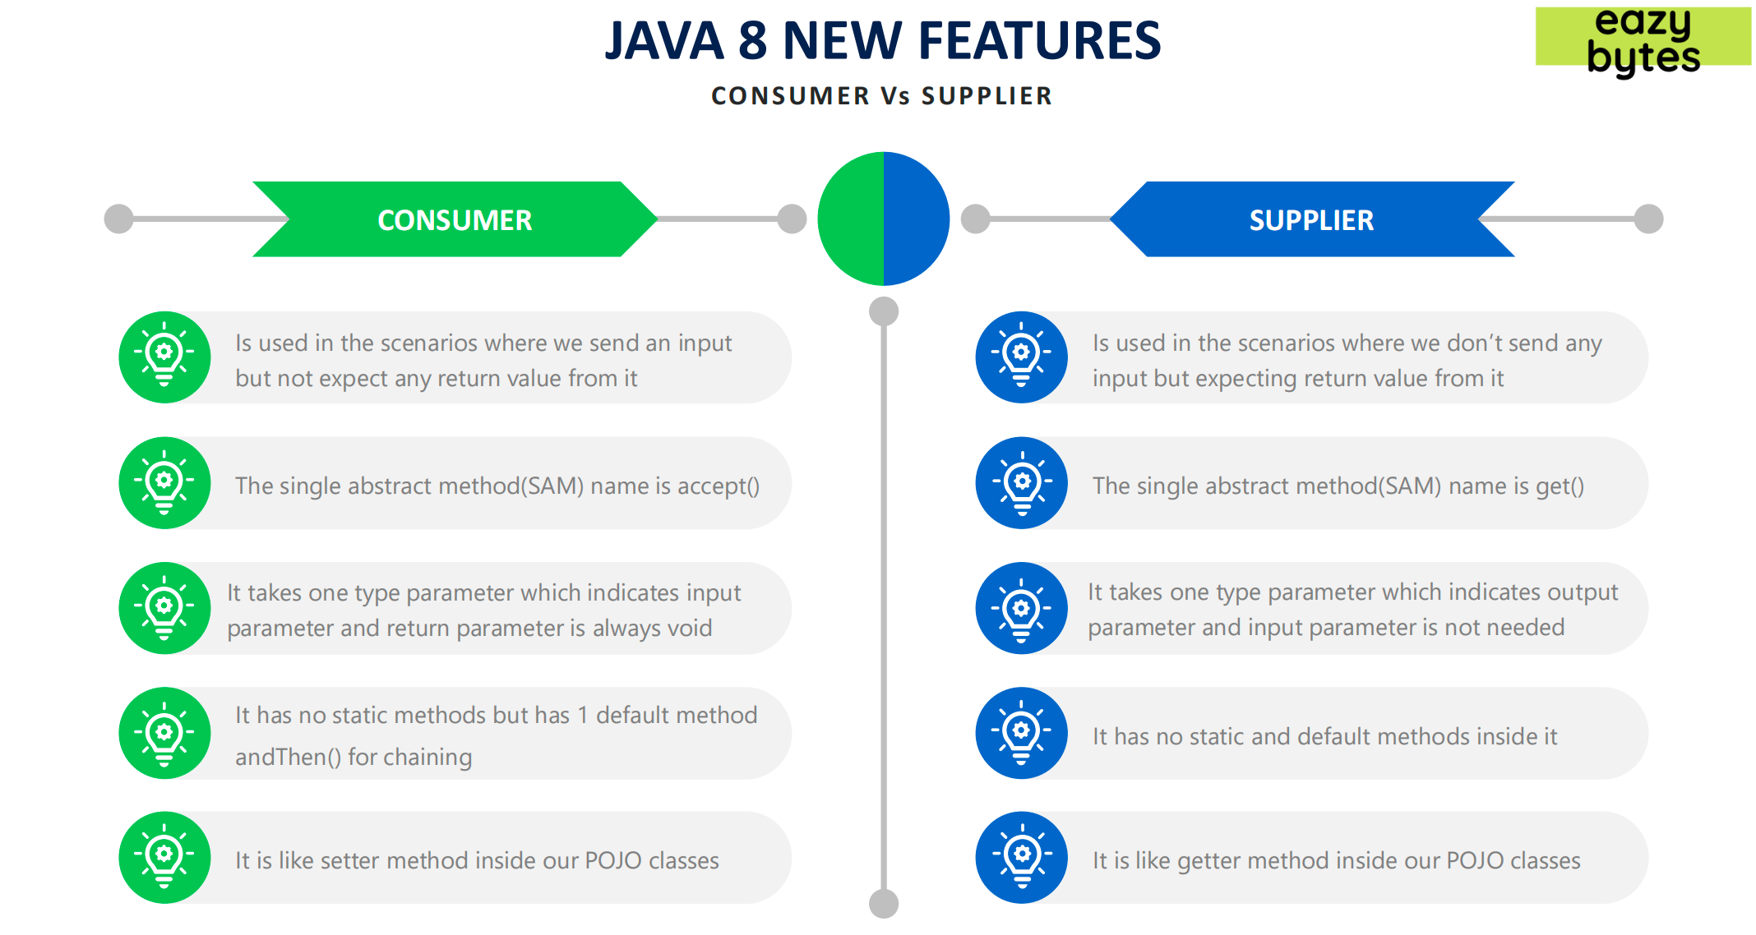

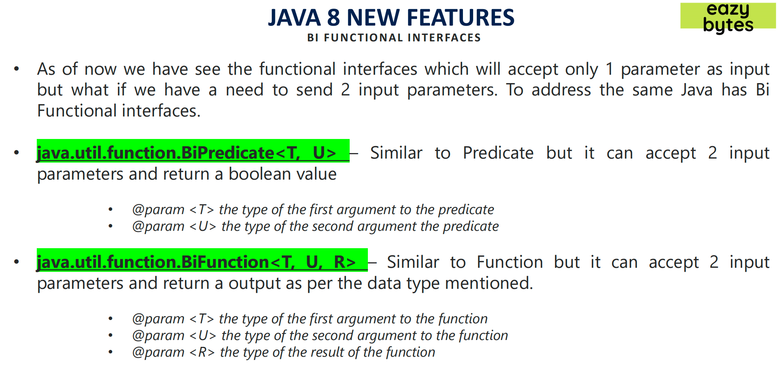

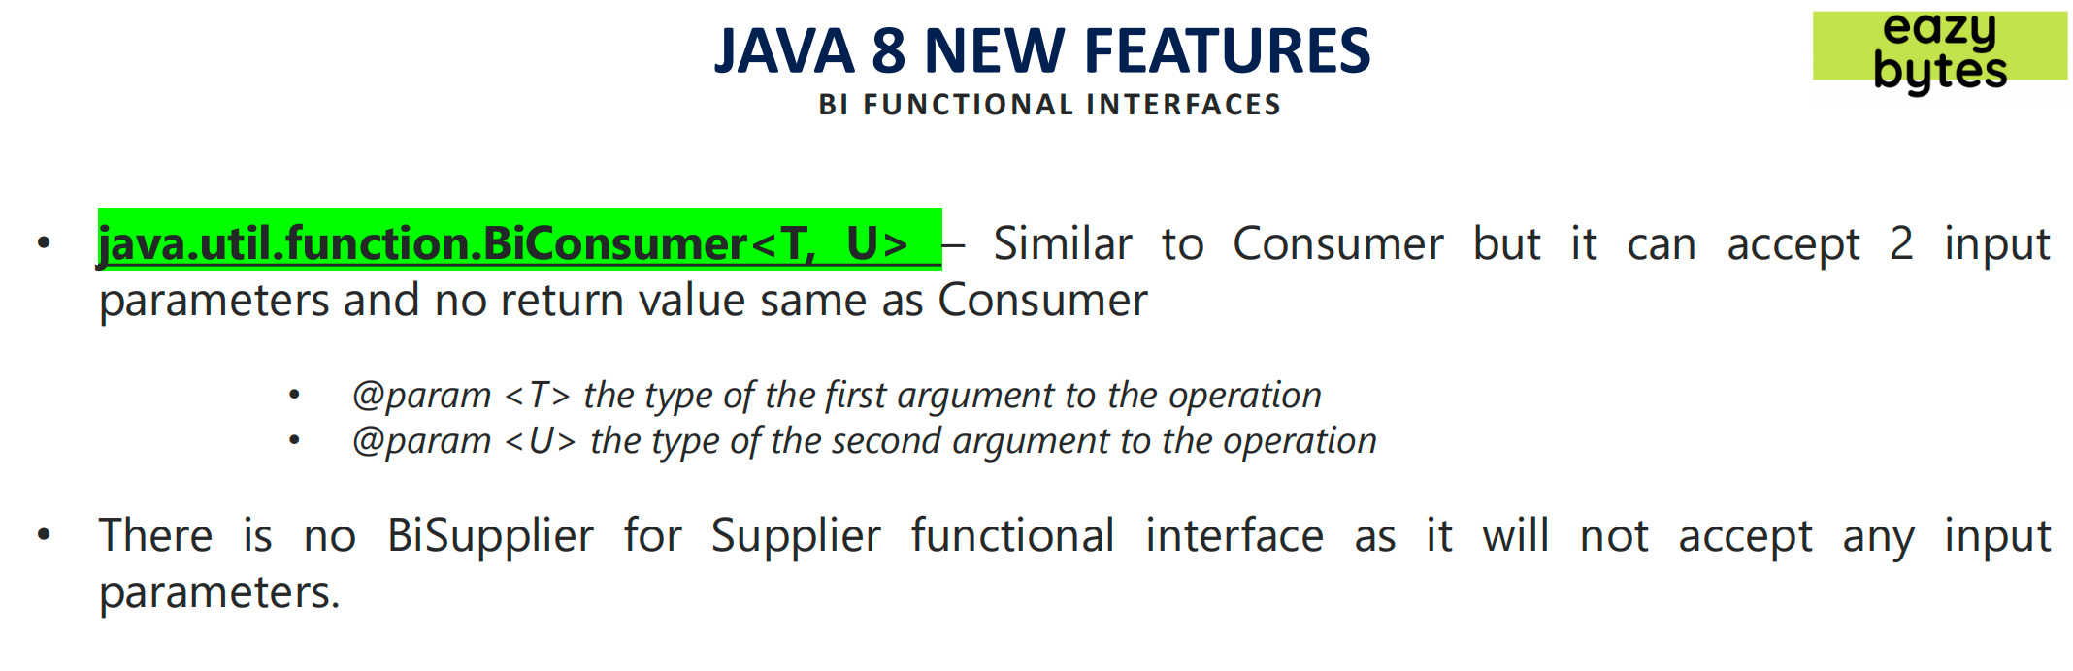

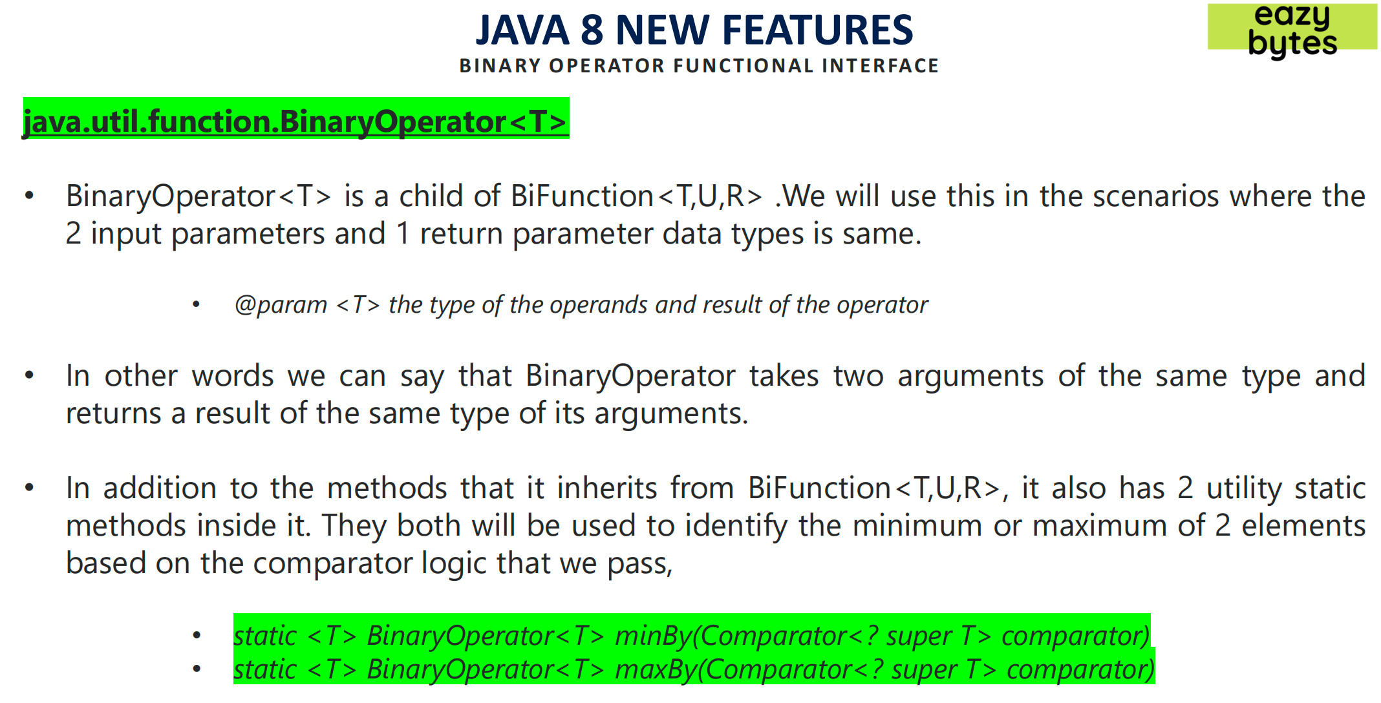

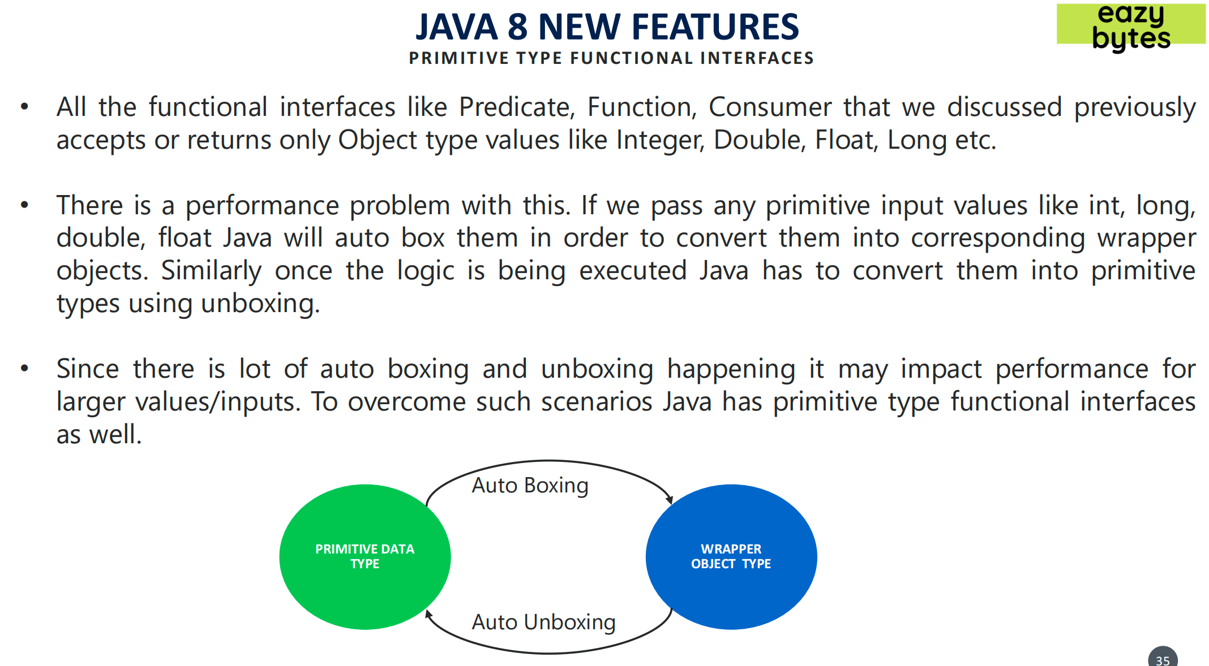

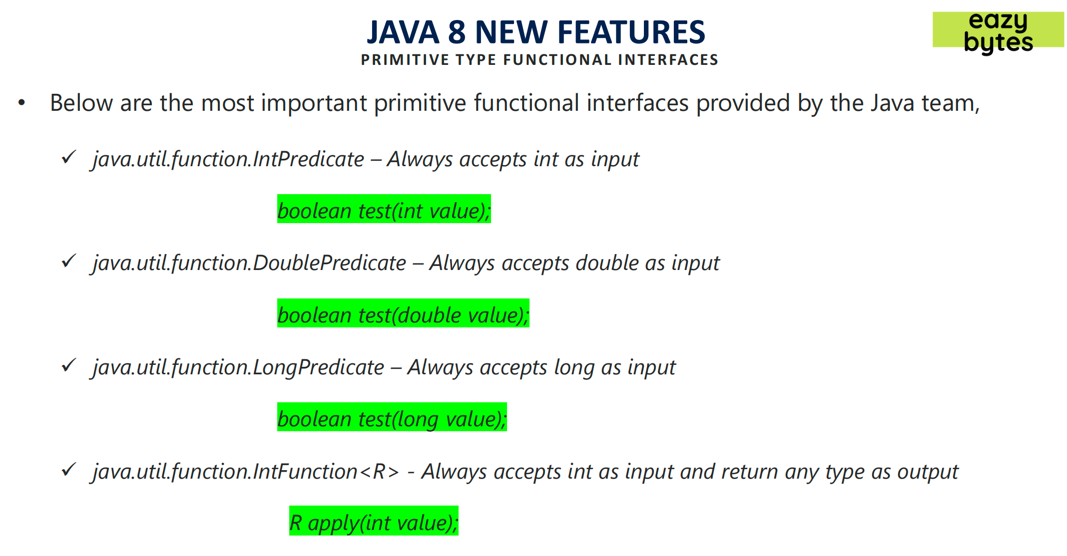

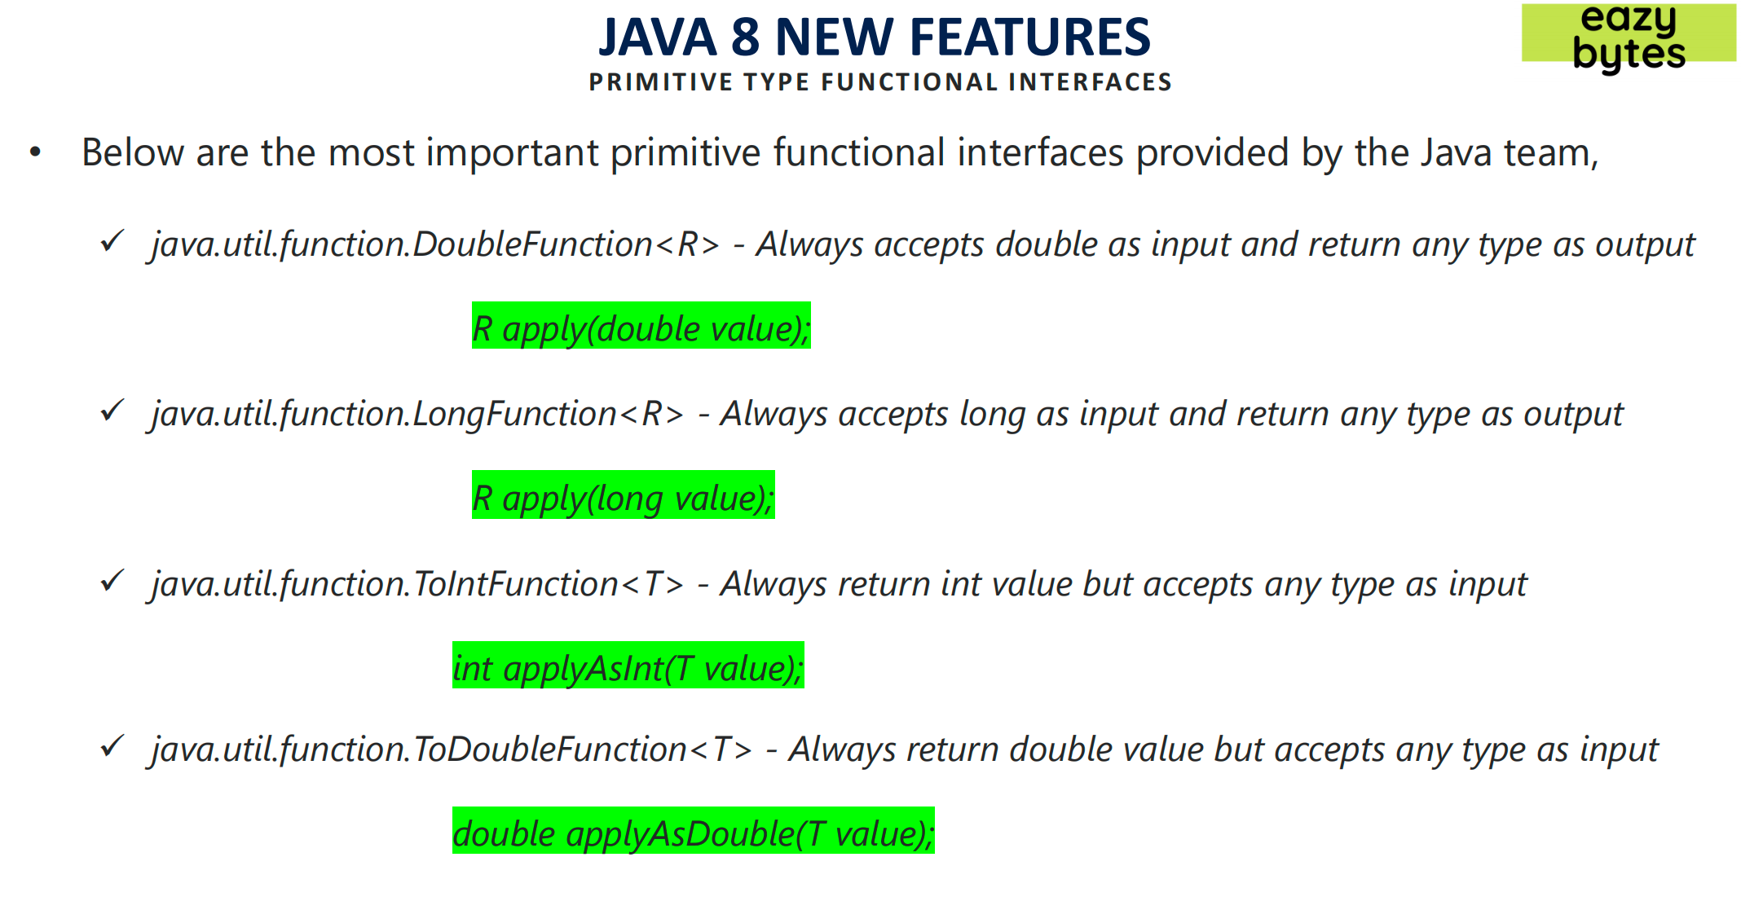

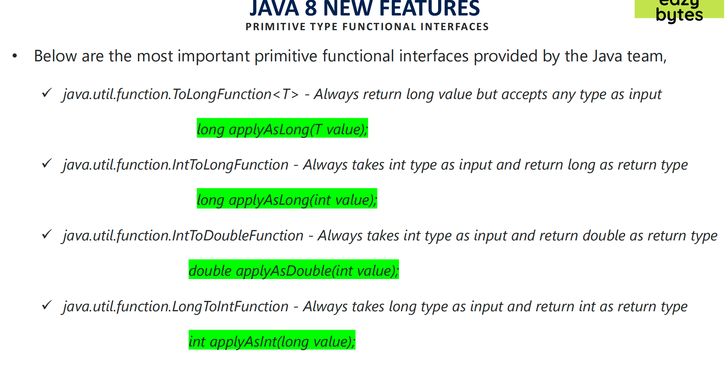

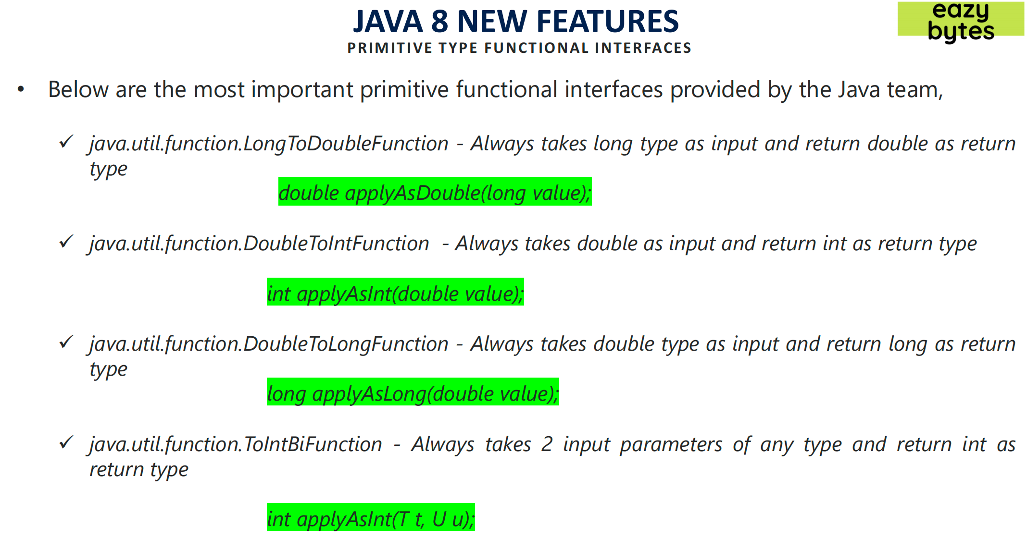

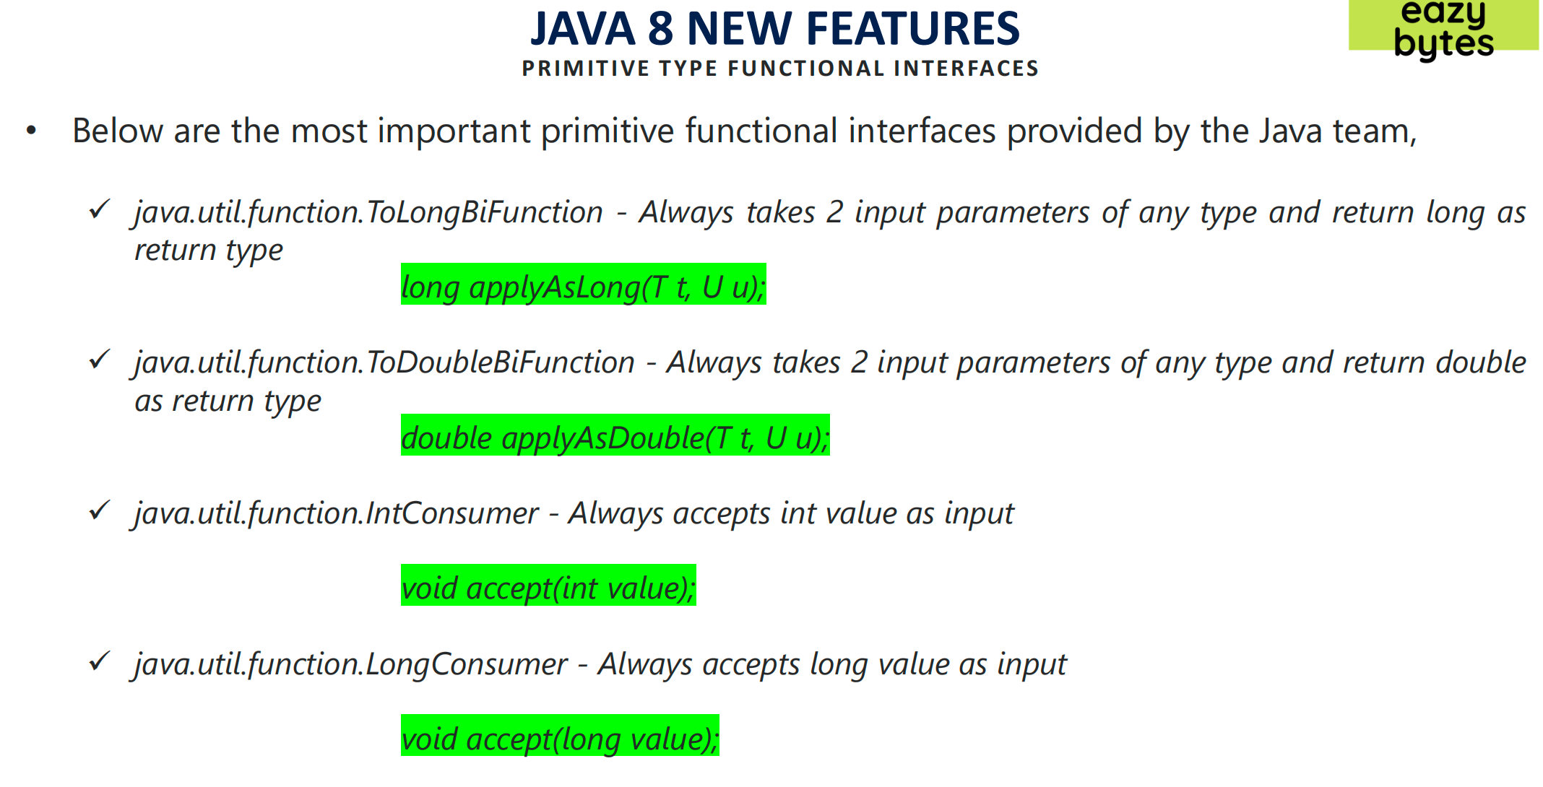

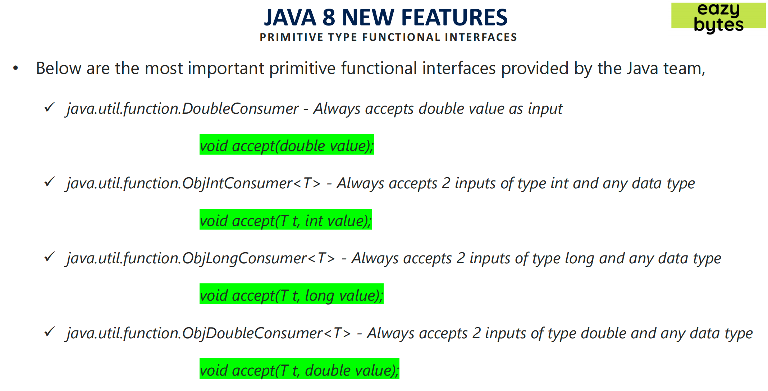

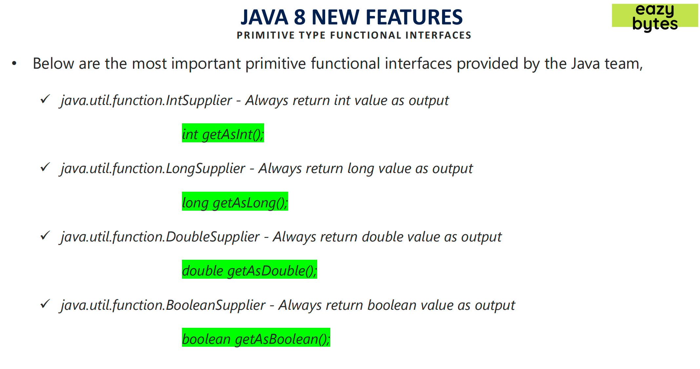

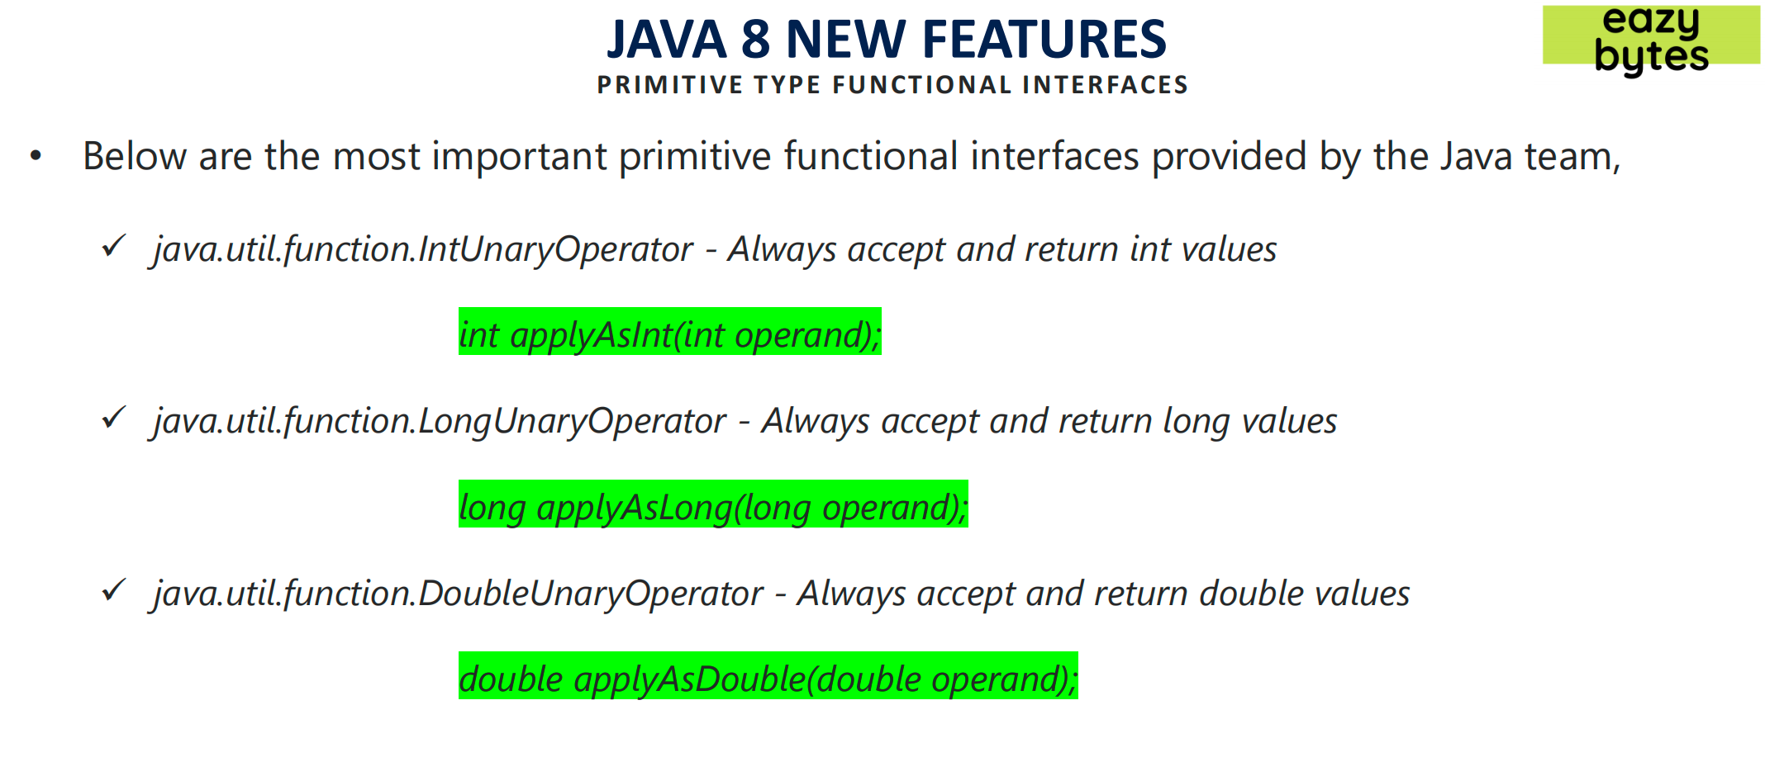

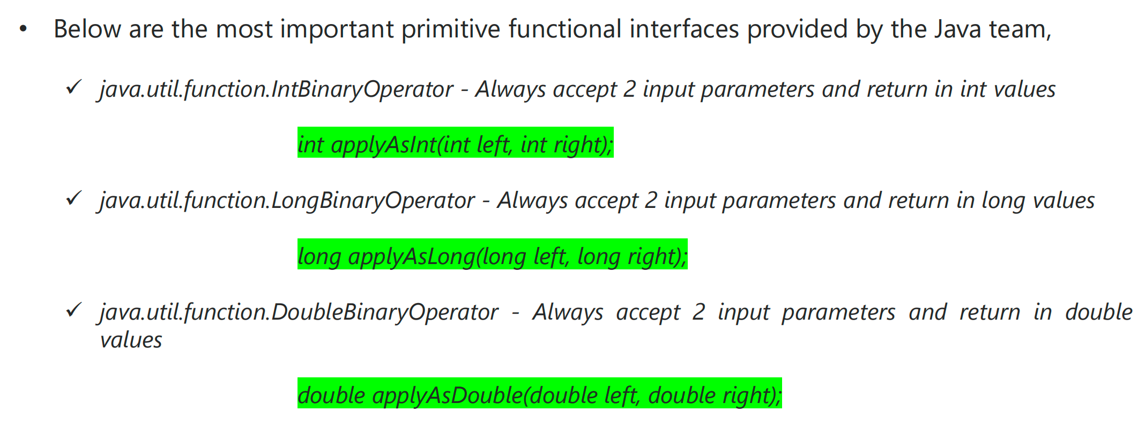

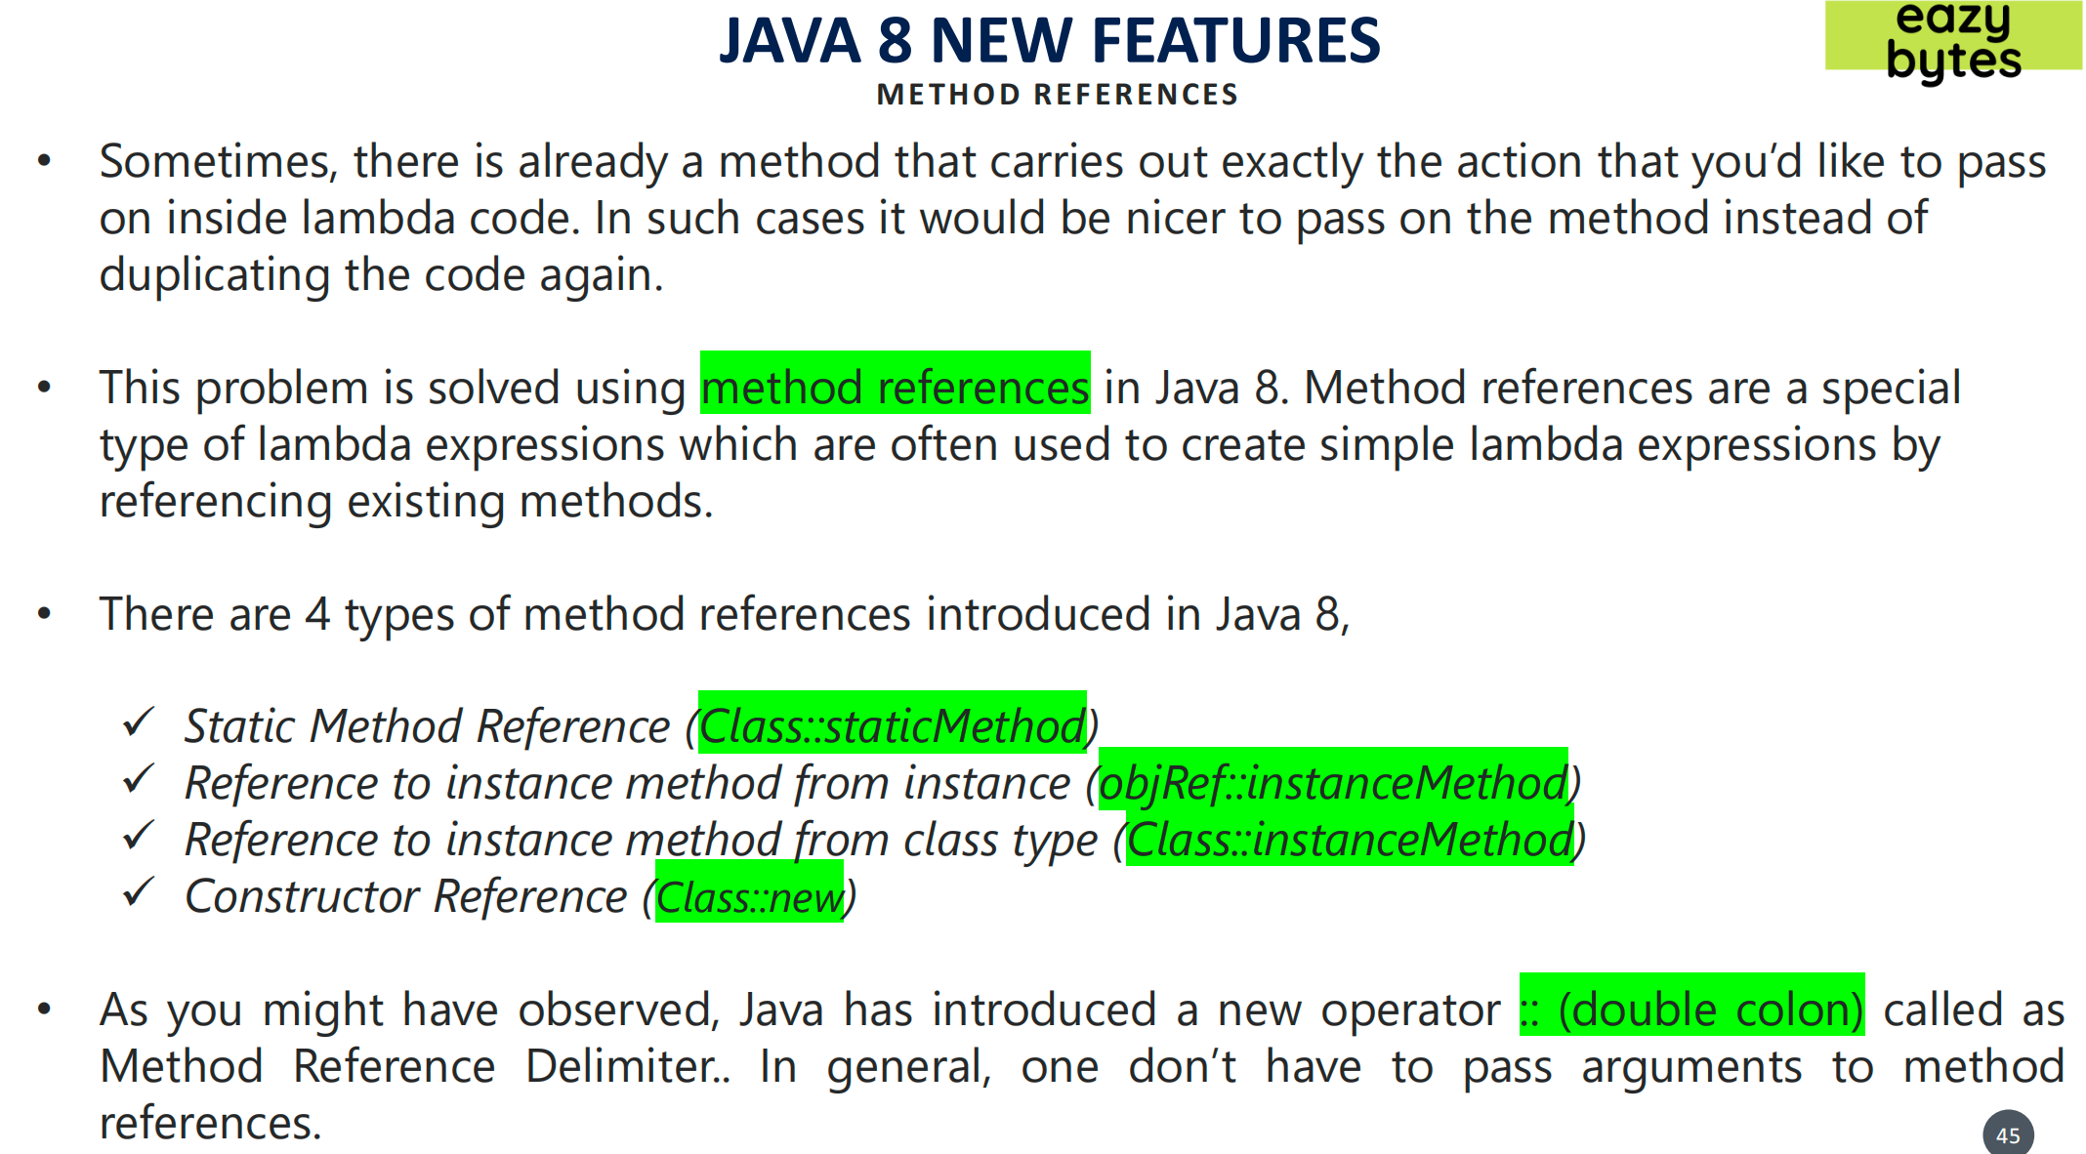

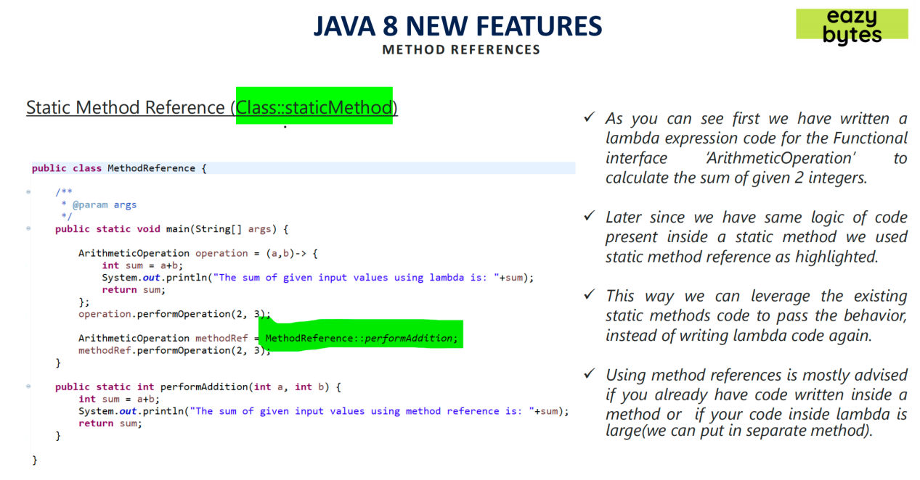

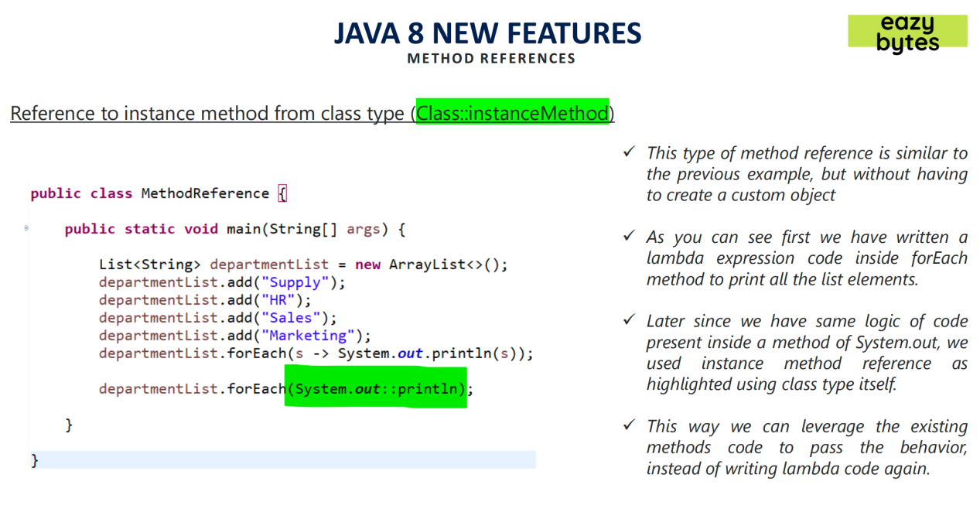

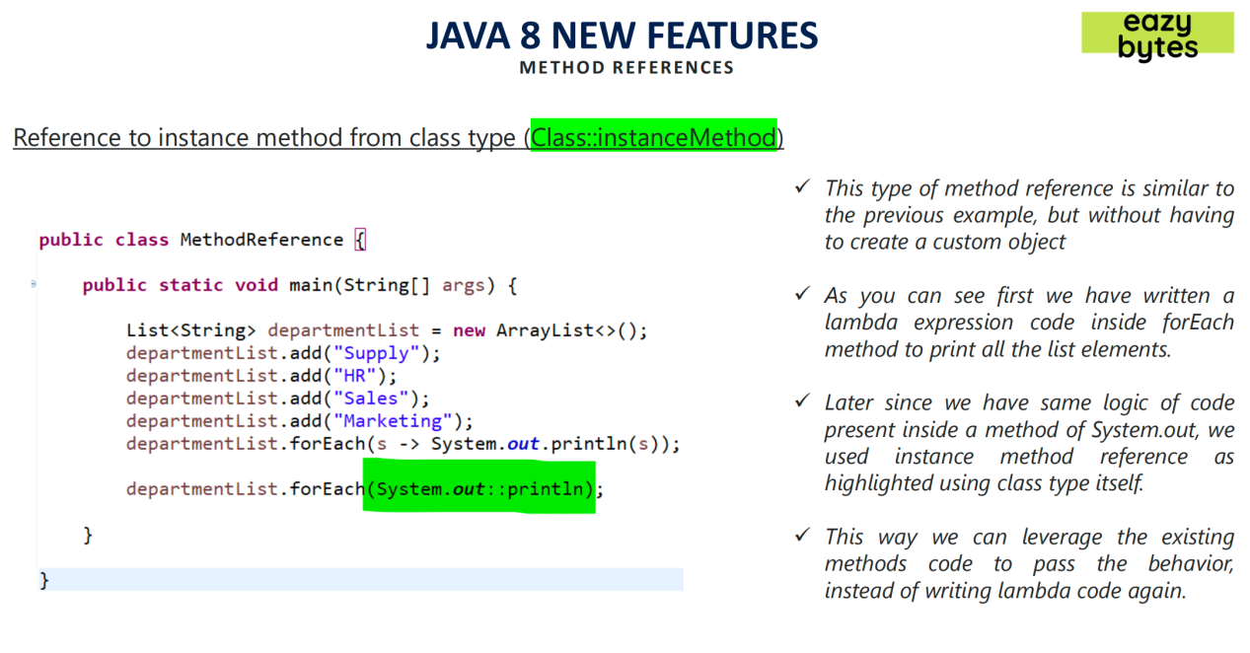

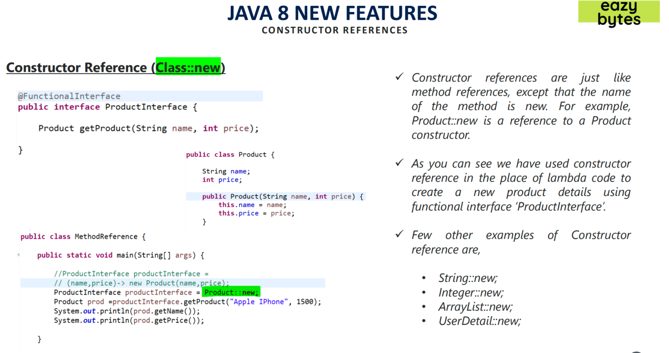

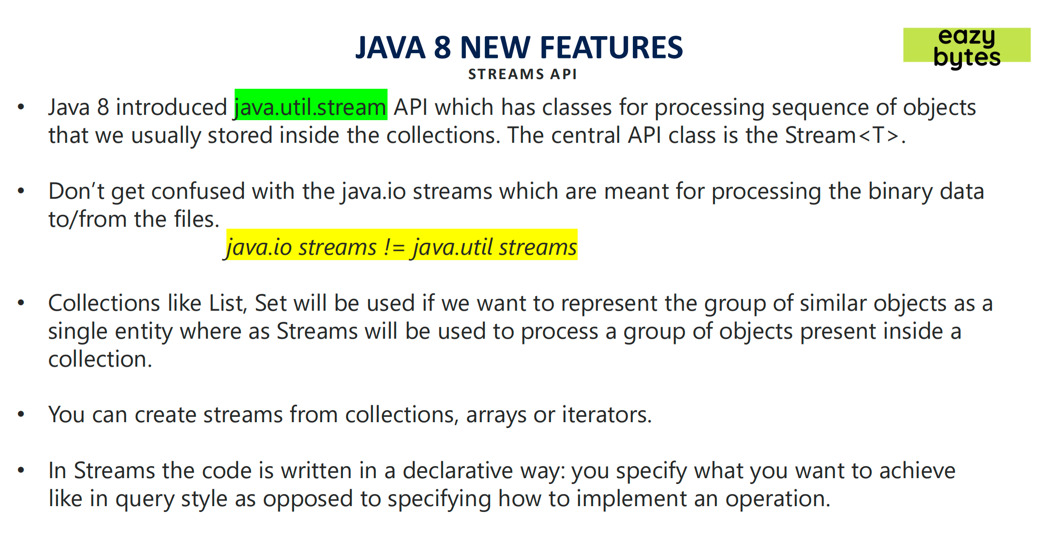

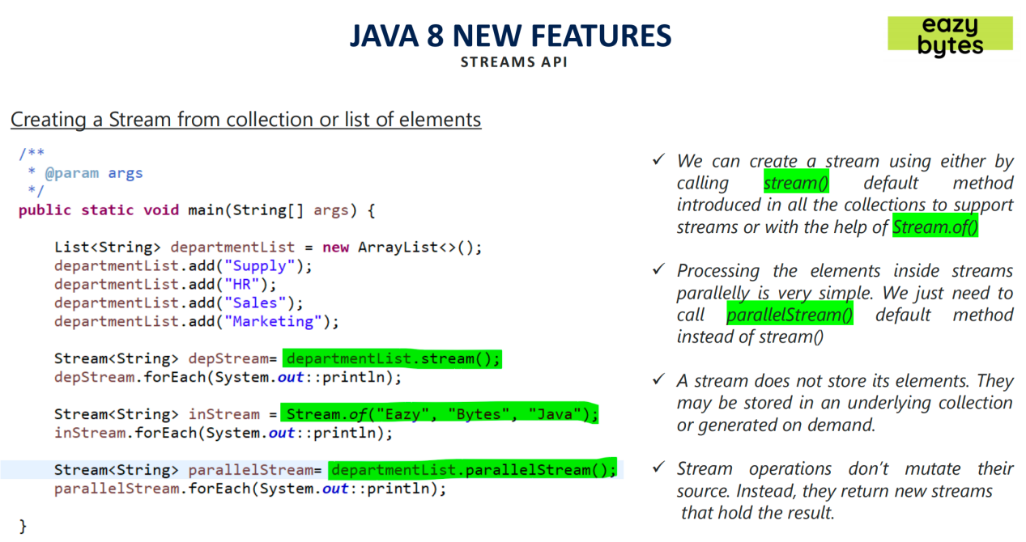

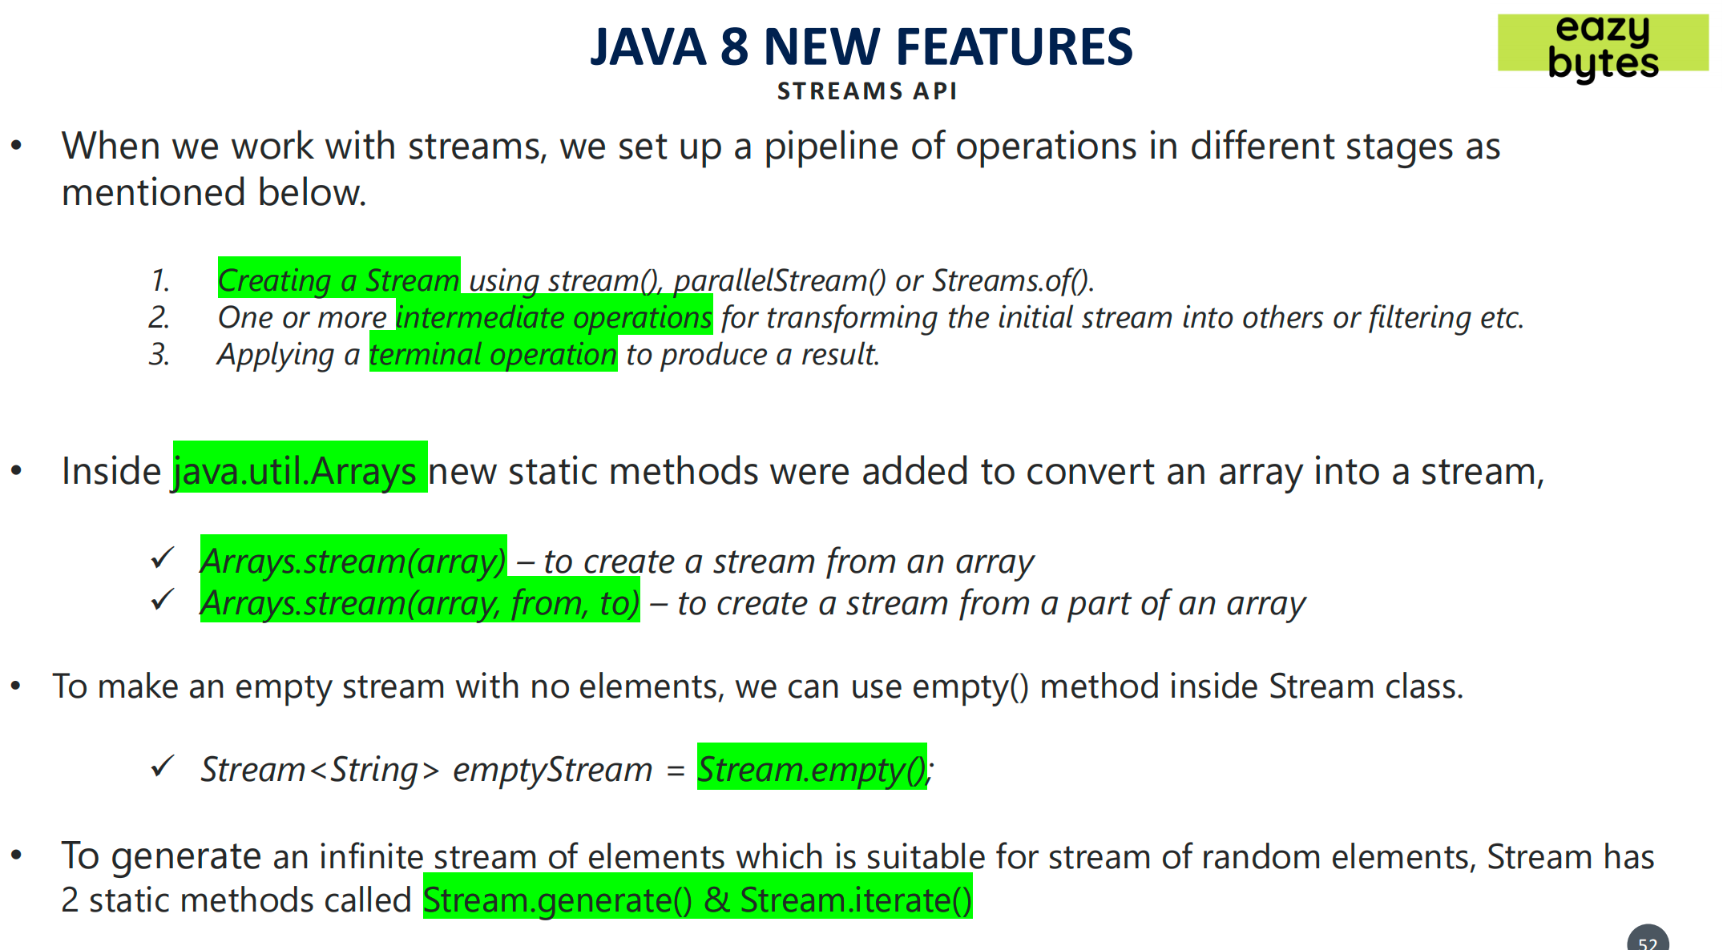

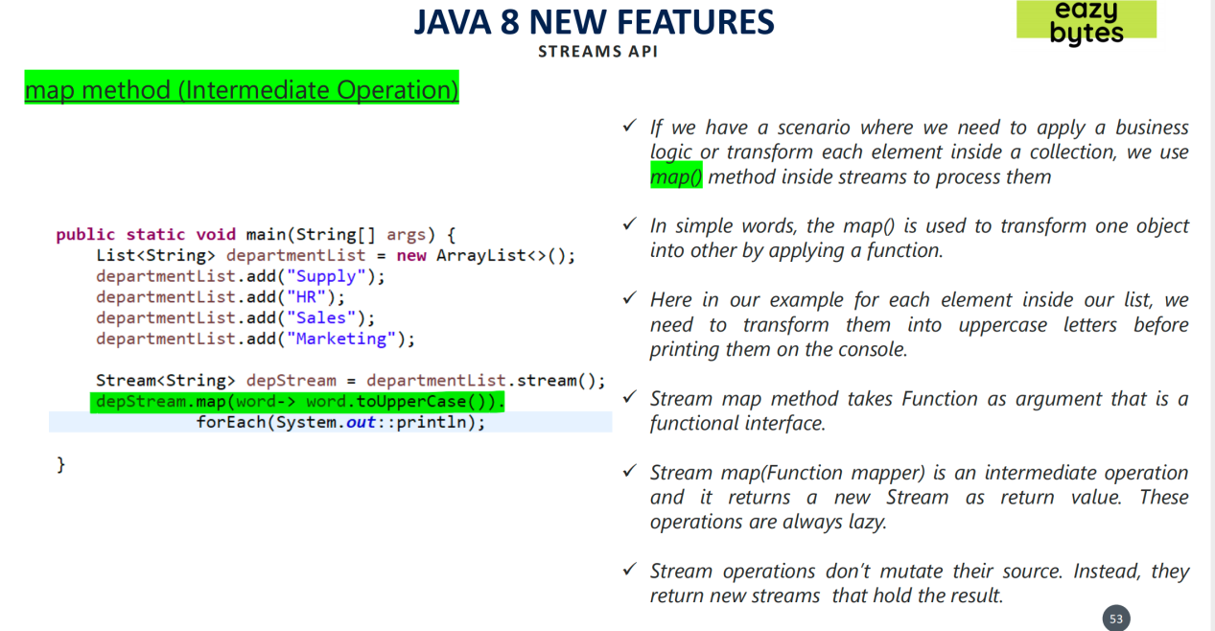

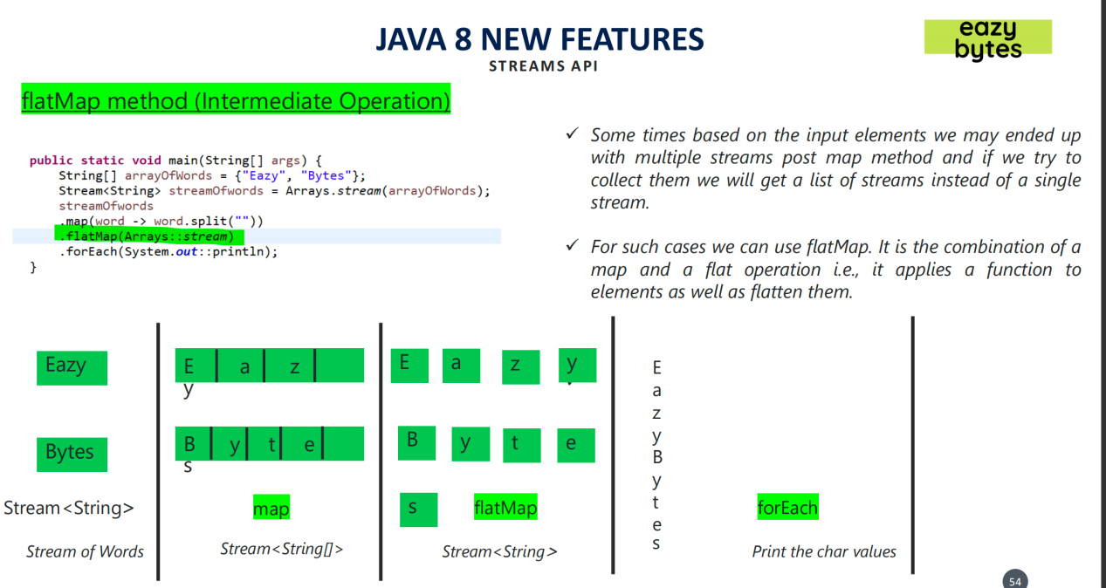

**Map vs FlatMap :**

In Java, the Stream interface has a map() and flatmap() methods and both have intermediate stream operation and return another stream as method output. Both of the functions map() and flatMap are used for transformation and mapping operations. map() function produces one output for one input value, whereas flatMap() function produces an arbitrary no of values as output (ie zero or more than zero) for each input value.

The Syntax of the map() is represented as:

<R> Stream<R> map(Function<? super T, ? extends R> mapper)

The Syntax of the flatMap() is represented as:-

<R> Stream<R> flatMap(Function<? super T, ? extends Stream<? extends R>> mapper)

Where R is the element type of the new stream. The stream is an interface and T is the type of stream elements and mapper is a stateless function that is applied to each element and the function returns the new stream.

map() can be used where we have to map the elements of a particular collection to a certain function, and then we need to return the stream which contains the updated results.

Example: Multiplying All the elements of the list by 3 and returning the updated list.

flatMap() can be used where we have to flatten or transform out the string, as we cannot flatten our string using map().

Example: Getting the 1st Character of all the String present in a List of Strings and returning the result in form of a stream.

